AR-24 U.S. Navy Repair Tender

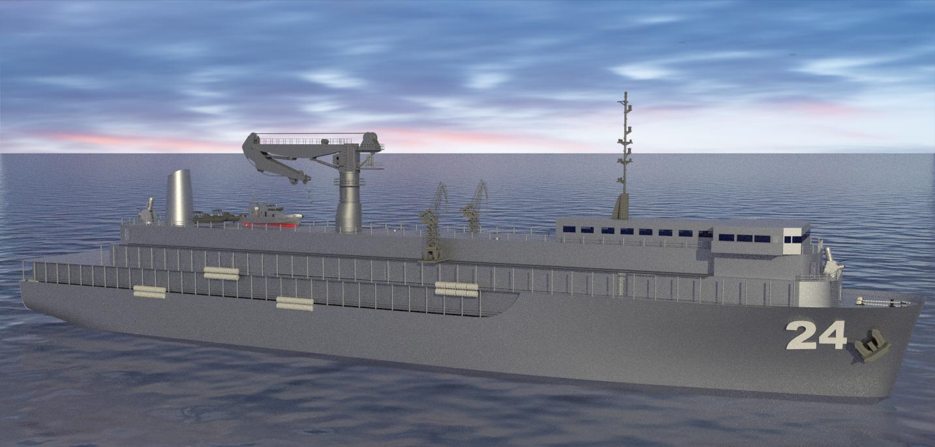



Designed by Midshipmen 1/C:
Lillian Freeman - Liam Nawara - JD Shaw - Reba Pamintuan

US Naval Academy: Repair Tender
James A. Lisnyk Student Design Competition
Student Team Members

The following members were part of the design team:

Student Name | Signature
Lillian Freeman | 
Liam Nawara | 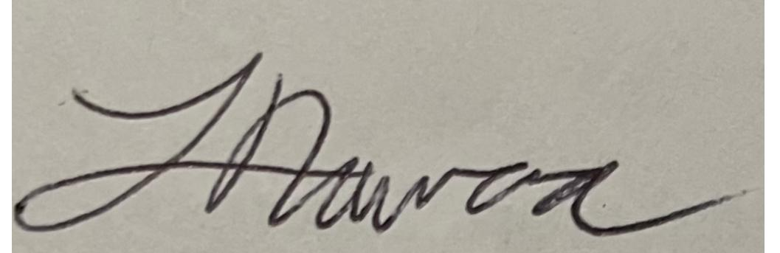
Reba Pamintuan | 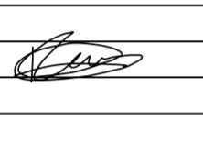
Jack Douglass Shaw | 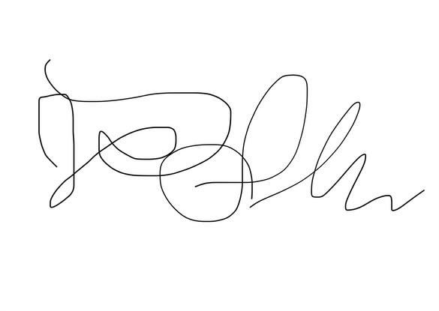

US Naval Academy: Repair Tender
James A. Lisnyk Student Design Competition
Faculty Advisor Statement

By this statement, I certify that the work done for this design competition was completed by the student team members.

Faculty Advisor

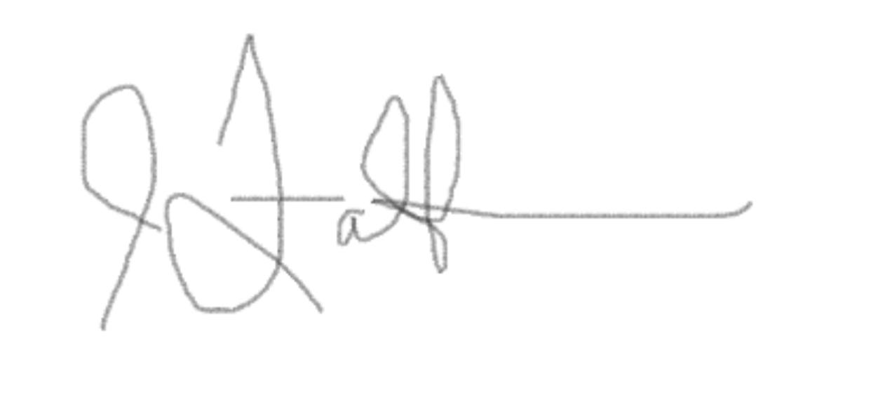
_____________________________
Dr. Jaye Falls

Table of Contents
Mission 3
Report Summary 3
Table of Principal Characteristics 6
Concept Selection 7
Initial Definition 7
Parametric Analysis 13
Hull Form Development 21
Load Line Freeboard and Bow Height 24
Curves of Form 25
Floodable Length Curve 27
Area and Volume Summary 28
Structural Design 28
Load Plate Structural Analysis 28
Load Stiffener Calculation (One Bay) 29
Global Bending Analysis 31
Hull Section Modulus 31
Propulsion Trade-Off Study 33
Specific Prop and Reduction Gear Selection 35
Electrical Load Analysis and Sizing 38
H,M, & E Systems 39
Main Machinery 39
Piping Systems 40
Electric Generation System 42
Mission-Related Systems 43
Overhead Rail System 43
Defensive System 43
Dive Operations and Underway Husbandry System 44
Margin for Future Industrial Technologies 44
Weight Estimate 44
Trim and Intact Stability Analysis 46
Speed-Power Analysis 48
Holtrop Speed/Power Analysis 48
Series Selection 49
Taylor Series Resistance Estimate 49
BHP Prediction 50
Endurance Calculation 53
Seakeeping Analysis 54
Manning Estimate 58
Cost Analysis 60
Risk Assessment 62
Appendix 63
Appendix A. Lines Drawing 64
Appendix B. General Arrangements 65
02 Level 65
01 Level 66
Main Deck 67
1st Deck 68
2nd Deck 69
3rd Deck 70
Appendix B. Capacity Plan 71
Cargo Holds Tanks (Bilge Deck) 71
Midship Section Drawing 72
Appendix C. Machinery Arrangement 73
Table of Principal Components 73
References 75

Mission
The mission of the AR-24 is to provide battle damage assessment and repair support to
damaged surface ships in expeditionary environments. The AR-24 has latent capacity to provide
Intermediate level Maintenance Activity support away from established shore facilities. The
repair tender will be designed for expected operations in the US Indo-Pacific Command Area of
Responsibility.

Report Summary
The reductions in the US Navy’s force structure following the conclusion of the Cold War have reduced the Navy’s capability to sustain expeditionary naval combat operations against a peer adversary. The US Navy (USN) divested its destroyer tenders, repair tenders, floating drydocks, salvage vessels, and other critical auxiliaries in the dawn of the 21st Century. Changing operational demands of the Global War on Terror forced a reduction in the US Navy’s size. With the need to contest the rise of an authoritarian and assertive People’s Republic of China, the US Navy now has an operational need to reestablish battle damage repair capabilities in expeditionary environments in its force structure (Prouty, 2022). The 2018 National Defense Strategy emphasizes the Department of Defense’s need for “non-commercially dependent logistics and maintenance” (Strategy, 2022). The US maritime strategy Advantage at Sea states that “logistics and auxiliary ships will surge to establish refueling, rearming, resupply, revive, and repair points” (Prouty, 2022).

The US Navy’s current battle damage repair capabilities are currently insufficient to handle even singular ship damage incidents. Admiral Daryl Caudle, US Fleet Forces Command highlighted the Navy’s inability to conduct emergent wartime repairs in 2022 speech where he stated that “If I went into conflict, high-end conflict where I had to repair numerous ships simultaneously, I don’t have enough capacity. I don’t have enough dry docks, and I don’t have enough shipyards to get after that” (Eckstein, 2022). In an expeditionary environment, logistics and challenges imposed by the distance from shore-based support facilities will pose an even greater limiting factor to repairing battle damage to surface vessels.

Additionally, many shore-based repair activities and shipyards may find themselves within the range of adversary long range fires in the opening stages of a conflict (Gonzalez, 2017). The People’s Liberation Army Rocket Force can hold many shore-based facilities in the Indo-Pacific at risk to include repair facilities in Guam, Japan, Australia, the Philippines, and other potential allied states as well.

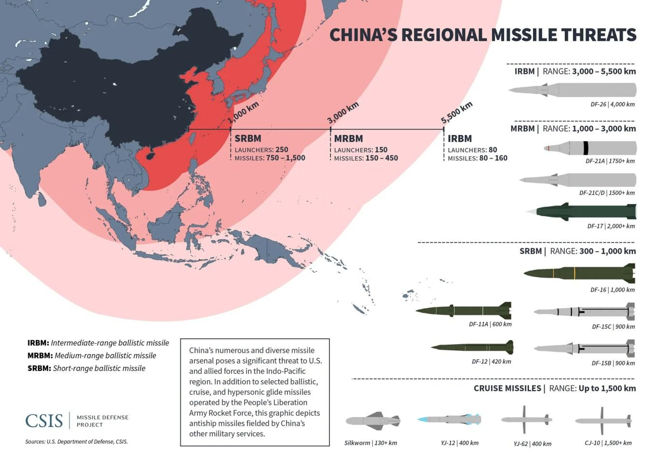
Figure 1. PLARF Weapons Engagement Zone in INDOPACOM AOR (CISIS Missile Defense Project, n.d.)
A new vessel, capable of conducting battle damage repair in forward expeditionary environments is needed. The US Navy lacks the ability to conduct expeditionary battle damage repair. A 2021 Government Accountability Office (GAO) report found that the USN has a “lack of established doctrine for battle damage repair, unclear command and control roles, and a shortage of repair capacity” (GAO, 2021). The USN’s current battle damage repair model is shown in figure 2. While this process is functional and capable of supporting emergent repairs, the USN does not have the salvage or repair vessels capable of supporting this doctrine in an expeditionary environment.

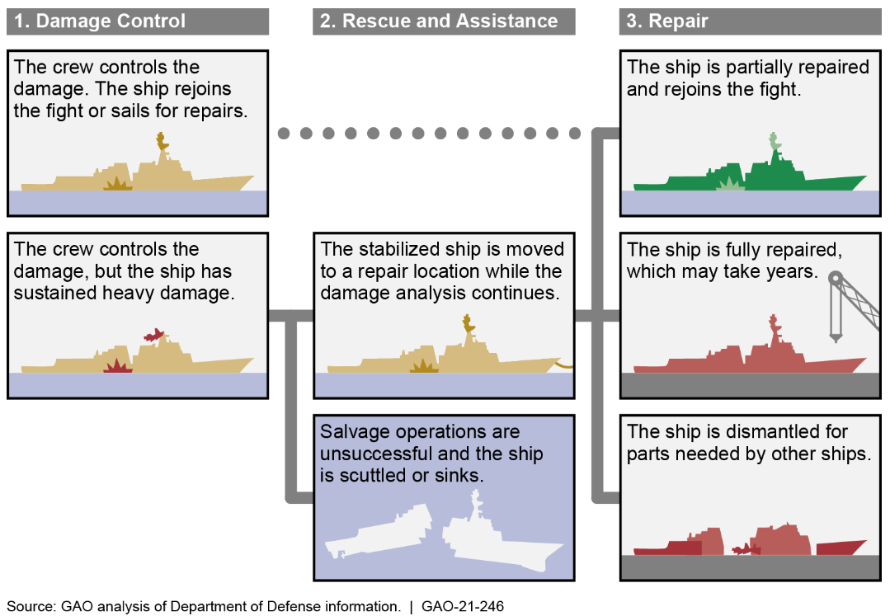

Figure 2. The Navy Process for Repairing Ships Damaged in Battle

Table of Principal Characteristics
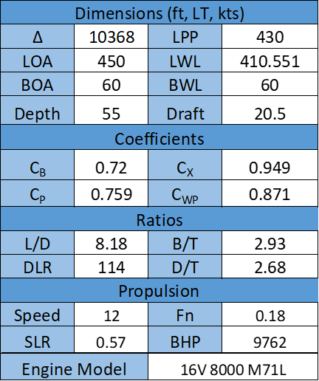
Figure 3: Table of Principal Characteristics

Concept Selection

Initial Definition
General: This circle of requirements (COR) is for a repair tender optimized to conduct battle damage assessment and repair to US Navy surface combatants. DDG-125 is used as the representative vessel to derive customer vessel needs. As a US Navy large surface combatant with a planned life expectancy into the 2060s, DDG-125 is an appropriate stand in for future growth margins in operational demands.

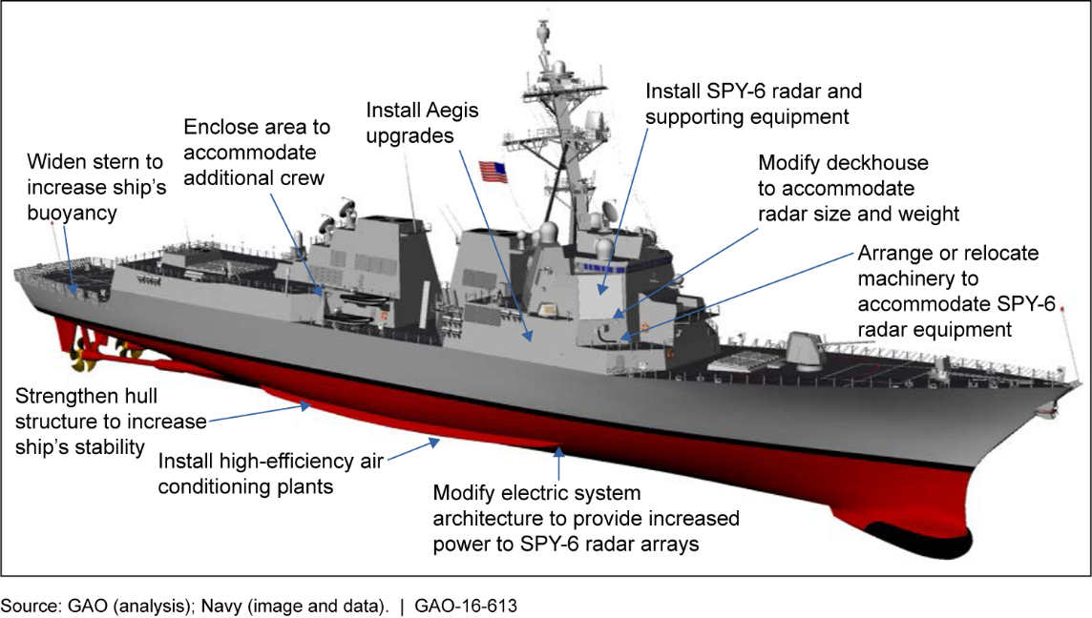
Figure 3. DDG-125 Vessel (Flight III Arleigh Burke Class Guided Missile Destroyer)

The required capabilities of the AR-24 include:

• Providing hotel services for customer vessel
• Caring for customer vessel casualties in medical facilities.
• Providing repairs to restore hydrostatic and structural stability to battle damaged ships.
• Providing stowage for damaged customer vessels to unload weapons stores (up to strike length Mk 41 VLS Canisters)
• Repairing ships in remote ports and in protected anchorages

The AR-24 must have sufficient modularity, commonality, and redundancy to remain fully operational and within its planned maintenance cycle. It must be reliable to complete planned maintenance and missions without degradation to operational capability. The design service life is 40 years. The AR-24 is planned as the lead hull of a three-ship class.

Missions: The following are missions of the AR-24.

- Expeditionary Battle Damage Repair and Assessment - The primary mission of the AR-24 is to provide the ability to support battle damage repair and assessment to damaged US Navy surface combatants in expeditionary environments. The intent is to restore customer vessel hydrostatic stability and maintain a level of operational capability to provide flexibility to combatant commanders.

- Intermediate Maintenance Activity (IMA) Level Support - The secondary mission of the AR-24 is to provide IMA level support to surface combatants and auxiliaries. This capability is provided by using the latent repair capacity of the tender to support peacetime miniatous requirements for surface combatants.

- Hotel Services- The AR-24 will be able to support surge berthing for 360 additional sailors in order to house the crew of one notional customer vessel. AR-24 will provide the needed hotel service, galley space, and administrative spaces to support the surge berthing of the customers vessel’s crew in order to complete maintenance on the vessel under repair.

- Medical Facilities- The AR-24 shall have medical facilities to include a full dental suite, x-ray capabilities, and space for surgery, isolation, and ability to provide general medical care.

LOA | 450 | ft
Beam | 60 | ft
Full Load Draft | 20.5 | ft
Full Load Displacement | 10,367.8 | LTSW
Maximum Trim by Stern | < 1% of the LWL
Table 1. AR-24 Sizing Requirements
Operational Area: The AR-24 will be optimized for use in the United States Indo-Pacific Command Area of Operations (USINDOPACOM). The vast area and distances between shore-based repair activities increases the operational utility of tenders in this region. The AR-24 is designed to operate in protected anchorages and austere ports in the USINDOPACOM AOR to enable operational flexibility. The AR-24 will be able to visit critical U.S. Navy bases such as Apra Harbor, Guam and Pearl Harbor, Hawaii.

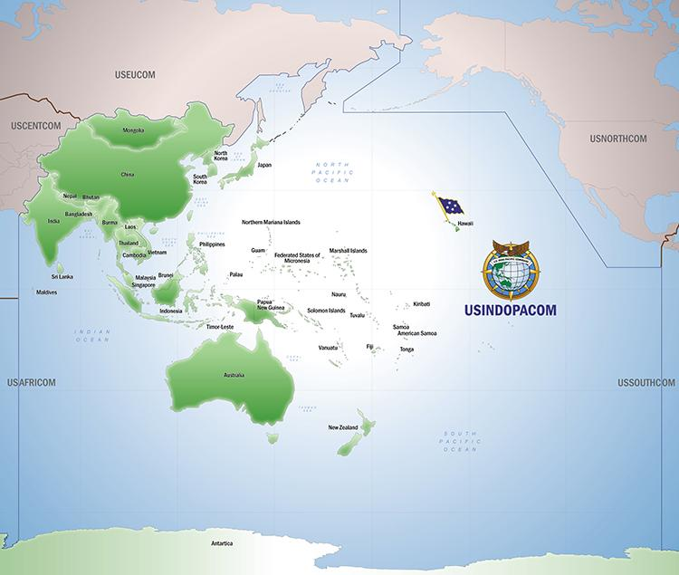
Figure 4. USINDOPACOM Area of Responsibility, (USINDOPACOM, 2022)
Operating Profile: The AR-24 will have sufficient provisions for 75 days without need for resupply. This includes time spent at anchor conducting BDAR operations.

Speed: The AR-24 shall have a maximum speed of 18 knots. This is informed by the hull form performance and operational requirements of the AS-39 Class which has a similar mission profile to the AR-24. The calm water cruising speed will be 12 knots. The AR-24 can sustain a speed of 13 knots, enabling refueling at sea and underway replenishment operations.

Range: Sufficient fuel for 4,500 NM at the full load displacement and 12 knots with a 10% reserve is required. This enables transit between major US Navy Bases across the USINDOPACOM AOR. This enables freedom of operational maneuver in theater.

Accommodations: Accommodations and facilities for 933 are required. The repair tender will embark an all US Navy crew. The mission profile requires sufficient personnel to operate the ship and conduct expeditionary BDAR. The vessel’s expected organizational structure requires 11 Officers and 800 junior enlisted sailors (E-1 to E-6) in addition to 36 Chief Petty Officers (CPO), Limited Duty Officers (LDO), and Chief Warrant Officers (CWO). To support this crew structure and provide a 10% margin for future crew expansion, 13 Officer berths, 40 CPO/LDO/CWO berths, and 880 junior enlisted berths will be provided. Berthing must support male and female berthing. There will be sufficient berthing to accommodate the multiple crew gender ratios. Each stateroom will be equipped with racks, storage drawers and hanging lockers. Each stateroom shall have a sink and a desk chair. All berthing shall provide ample storage including under rack storage, a hanging locker, to include space that can be secured for personal valuables. Heads and showers will be in the vicinity of both staterooms and berthing. Each head will have multiple toilets, sinks, shelves, and mirrors. Berthing shall meet NAVSEA habitability requirements.

Galley: There will be 2 galleys. One for the ship’s mess and the officer’s wardroom. Both galleys will be provided with sufficient resources (reefers, freezers, ice machines, microwaves, ranges with ovens, trash compactor, dishwasher, sinks, counter cabinet, storage, etc.) to effectively conduct hotel services.

Mess Deck: There will be two mess decks and wardroom with fixed tables and benches (seating for 694 at one time) conveniently near the galley. This space will also be used as crew lounge, classroom space, and meeting space when not in use for meals. Mess decks are a critical dual use space for supporting the response to mass casualty events with a secondary role as a combat aid station and area to stage damage control responses from.

Laundry: The AR-24 shall have a laundry space that contains self service and industrial washers and dryers. Additionally, the laundry space shall have the ability to support ships dry cleaning.

Hull: A displacement steel monohull is deemed most useful for this designed. Steel superstructure is preferred. Subdivision shall satisfy all Navy standards for safety laid out in DDS-079.

Propulsion: Marine diesels sufficient to sustain cruising speed at 85% of rated power or less are required. To support redundancy the ship shall have two propellers on two shaft lines. The propulsion train should be chosen so as to maximize propulsion efficiency. The AR-24’s propulsion train shall meet survivability standards for the US Navy and support operational redundancy. Adequate rudders should be used to support maneuvering.

Electrical: Adequate marine diesel generators shall be outfitted for the ship. Each generator should be a self-sufficient unit. Electrical considerations must also consider an emergency generator that can support basic functions on the ship including defense, navigation, maneuvering, and basic service for crew health such as HVAC and galley services.

Fire Fighting: The ship shall adhere to all regulations regarding US Navy Fire Fighting and Damage control.

Classification: The AR-24 will be classified using ABS rules. The AR-24 will be designed, built, and classified in accordance with Navy shipbuilding regulations and will support stability requirements outlined in DDS-079. The designation AR classifies the ship as a repair tender in the United States Navy.

Outfitting: All spaces are to be constructed to be easily maintained. A low- and high-pressure air system are necessary to carry out a variety of repair tasking. Potable water systems, pumps, tanks, treatment, and distribution systems must be installed. All personal protective gear must be outfitted completely on ship for firefighting, flooding, and other damage control causalities.

HVAC: Heating, ventilation, and air conditioning (HVAC) are required as outlined in the NAVSEA Ship Habitability Guide.

Exterior Decks: All exterior deck areas must have access to electrical power and the high- and low-pressure air systems. A high-pressure fresh water washdown system is necessary for both corrosion mitigation and for CBRN attack decontamination.

Mission Modules: The AR-24 will have deck space to support 2 mobile 10 ton cranes to complete repairs on ships. The AR-24 will also have a centerline 35+ ton crane. These cranes will also be capable of VLS reloading in protected anchorages.

Life Rafts: The AR-24 shall have two rigid hull inflatable boats (RHIB) to support survival of life at sea requirements. Additionally, AR-24 shall carry sufficient rapidly deployable, inflatable life rafts.

Tankage: Adequate tankage or storage for the design endurance must be provided for fuel, lube oil, trash, and potable water. All tanks should have a capacity of 110%. All tanks shall be corrosion resistant.

Anchoring: Two primary anchor, and one back up anchor shall be put on the ship. An electro-mechanical windlass shall be installed in conjunction to operate the anchor. Three anchors are required to support Mediterranean mooring.

Mooring: Bitts, chocks, and mooring cleats should be on the ship in order support alongside mooring. Mediterranean mooring must be supported to allow customer vessels to moor alongside the tender.

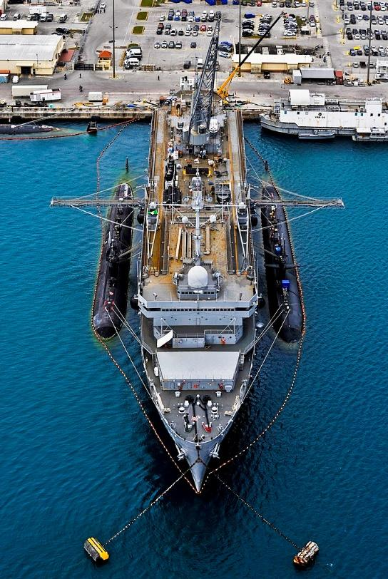
Figure 5. Example of Tender Supporting Customer Vessels in a Mediterranean Mooring
Underway Replenishment: The AR-24 will be designed so that underway replenishment can support extended operations at sea. The AR-24 shall have port and starboard refueling at sea (RAS) stations. The flight deck will also support vertical replenishment operations and personnel transfers.

Dive Operations: The ship must be able to support an onboard, or embarked fly-away team, of Navy Divers to include Navy Diving and Salvage Officers. The AR-24 shall support a 45-foot dive launch to enable underwater repair operations. Space will be sufficient on the deck to support an expeditionary recompression chamber.

Combat Systems: The AR-24 will have sufficient combat systems to support anti-terrorism force protection, point defense, and defensive decoy systems such as chaff launchers, CIWS, small arms, and 25mm cannon.

Administrative Facility: Administrative facilities should be ample on ship to support shipboard
functions, as well as supporting the administrative functions of the customer vessel

Navigation/Positioning/Communication: The AR-24 shall have radars capable of all-weather surface radar, navigational radar, GPS, compass, autopilot, fathometer, anemometer, barometer, HF/VHF/UHF radios, SATCOM, air horn, fog bell, searchlight, signaling halyards, and other communication tools. The ship will support effective local command and control.

Parametric Analysis
A similar ship analysis of fifteen destroyer tenders, submarine tenders, and similar foreign ships provides the necessary background data for analysis and planning of the ships as summarized in Table 4. Figures 6 through 12 show the graphical representations of the similar ship parametric summary.
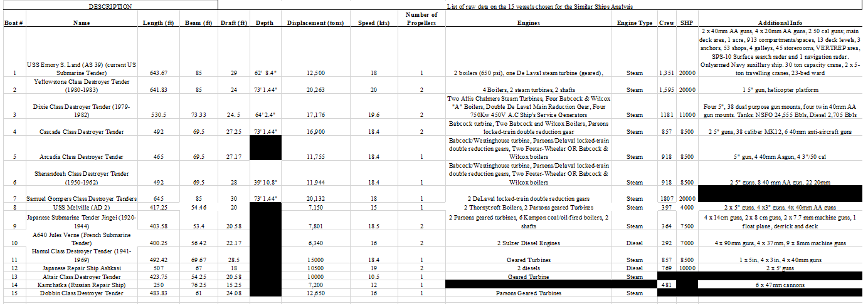
Table 2. Similar Ships Analysis
A series of design lanes were created to help to understand the current and past ships that the AR-24 will be most similar to. First, design lanes were created for the 15 similar ships showing the relationship between the beam and length of the ships. Figure 6 shows a rough estimate of where the AR-24 will fall, approximately a length of 450 feet and beam of 60 feet. In this design lane, the Russian repair tender, Kamchatka (data point called out), is significantly wider and shorter than all of the other ships.

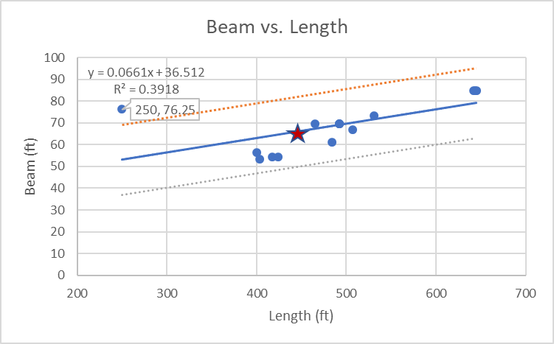
Figure 6. Parametric Analysis- Beam vs. Length

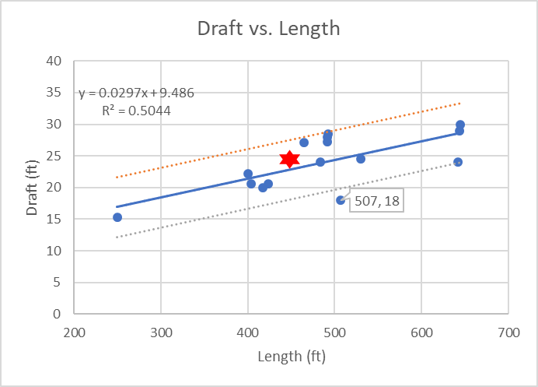
Figure 7. Parametric Analysis- Draft vs. Length

Design lanes were created for the draft versus length with all 15 similar ships. Figure 7 shows a rough estimate for the AR-24 will fall at a length of approximately 450 feet in length and a draft of 24 feet. The only ship in this design lane to fall out of the design lane was the Japanese repair ship, Ashkasi (data point called out), which has a length that is similar to its similar ships but a proportionally shallower draft

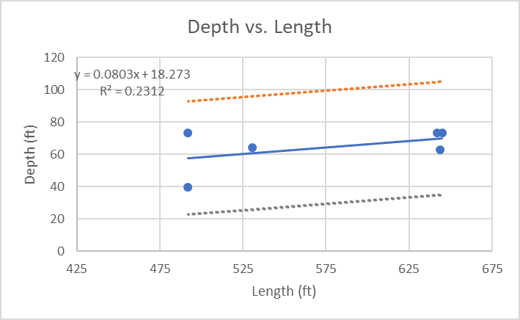
Figure 8. Parametric Analysis- Depth vs. Length
Design lanes were created for the six ships in which depth data was available. Depth data was collected using engineering estimates from vessel photos using known measurements as references for scale. The design lanes in Figure 8 show two main clusters of ship lengths, an upper and lower, the median trendline is that even for a ship with a length around 450 feet, depth will fall between 55 and 60 feet.
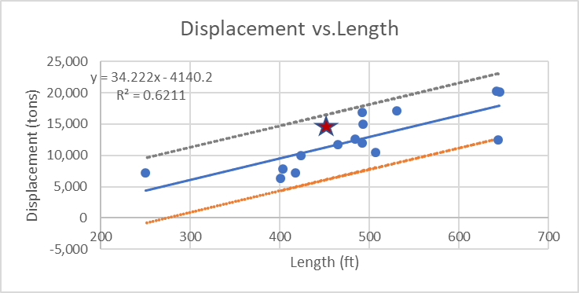
Figure 9. Parametric Analysis- Displacement vs. Length
Design lanes were created with all 15 similar ships to show the relationship between displacement and length. The only ship to fall outside, or on the outermost bounds of the design lanes, shown in Figure 9, was the Emory S. Lane (AS-39) which representative of the only active class of tenders in the U.S. Navy. The red star shows the estimation for the AR-24, with a length of approximately 450 feet and displacement of 14,000 long tons.
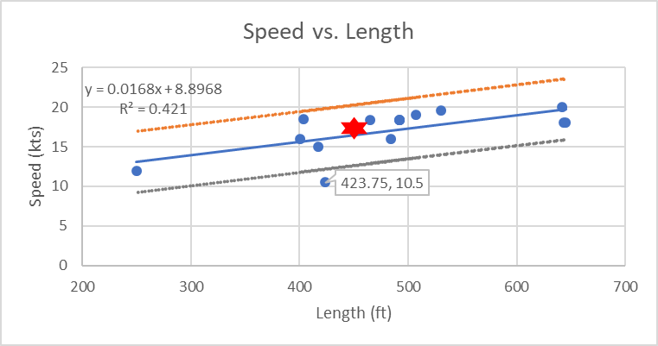
Figure 10. Parametric Analysis- Speed vs. Length
Design lanes, seen in Figure 10, were created for all 15 similar ships to show the relationship between speed and length and give an idea of the typical cruising speed of the AR-24. There is one outlier, called out, in this data set. The Altair Class Destroyer Tender has a cruising speed of 10.5 knots, making it much slower than similar ships with similar lengths. The red star shows the estimate that the AR-24 will be 450 feet in length and maintain a cruising speed of 16 knots.
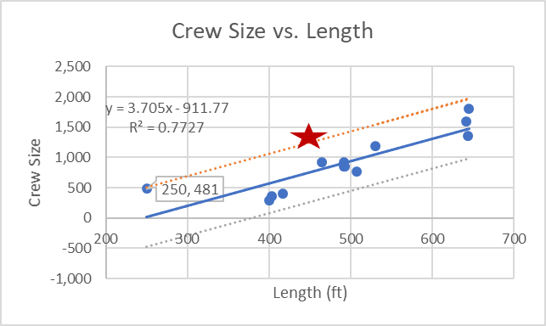
Figure 11. Parametric Analysis- Crew Size vs. Length
The crew size data was available for 13 of the similar ships and design lanes, shown in Figure 11, were created. Only one ship is a notable outlier, the Kamchatka, a Russian Repair Ship. This ship has a crew size of 481 people. Initial estimates put the crew size of the AR-24 at approximately 1,257 personnel. This number is based on the ship being capable of not only performing all of its functions but also provide hotel services for up to two full destroyers.
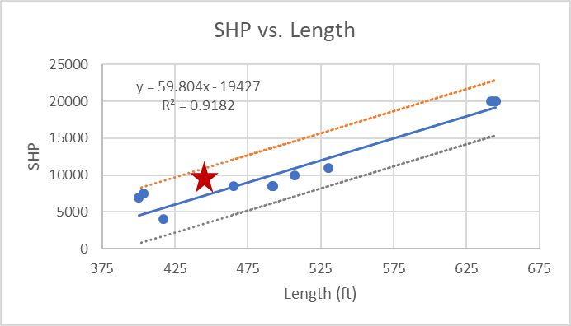
Figure 12. Parametric Analysis- SHP vs. Length
The final design lane created shows the relationship between Shaft Horsepower (SHP) versus Length, as seen in Figure 12. The shaft horsepower data was only available for twelve ships, and there were no significant outliers. The red star notes the estimate for the AR-24 with a SHP of 10,000 horsepower.
Current US Navy submarine tenders, built in the late 1970’s, are being used as the primary parent ship. A photograph of the parent hull, the Emory S. Land (AS-39) is shown in Figure 13 to better illustrate the design vision.

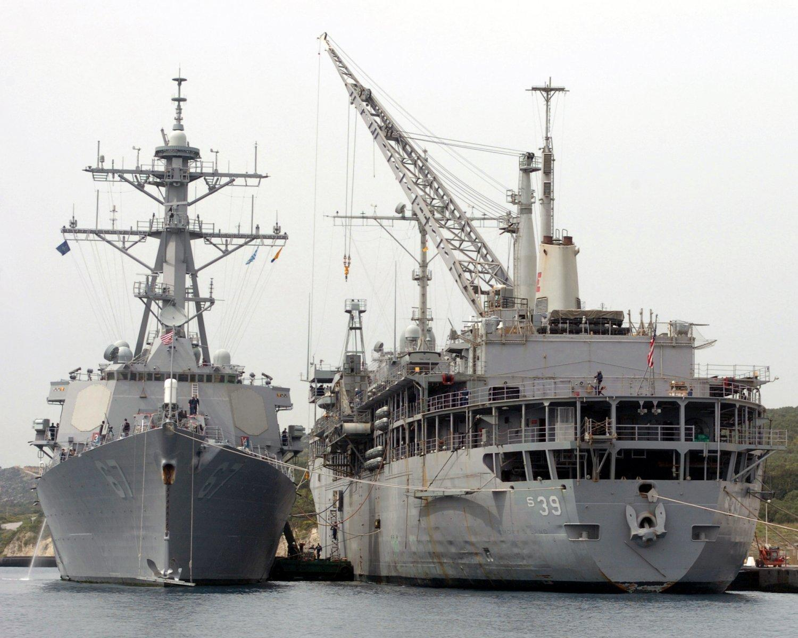
Figure 13. USS Emory S. Land (AS-39) repairs USS Cole (DDG-67) in Gaeta, Italy, 26 March 2006
The parametric ship analysis was informative in understanding the history of repair tenders throughout the United States Navy. Since the mission of the AR-24 Valkyrie is focused on surface combatants instead of submarines, the space requirements are less and the ship can be smaller. Internal volume requirements for submarine tenders include significant administration spaces for the planning of SUBSAFE qualified work packages. Other volume requirements from SUBSAFE that the AR-24 will not have to comply with include physical separation between SUBSAFE components and non-SUBSAFE components. The deletion of duplicated spaces and reduction in administrative space requirements decrease the volume requirements of the AR-24. The length of the Valkyrie is expected to be less than that of current submarine repair tenders. The AR-24 is to be similar to past designs, however a more scaled down version.

Hull Form Development
The design for the AR-24 Valkyrie was designed first from creating a list of requirements to solve the mission set of providing intermediate level maintenance activity in INDOPACOM. From this list of requirements, the next step was to complete a similar ships analysis of past surface repair tenders, submarine tenders, and other tender-style vessels. These ships fulfilled the mission requirements laid out and helped to create design lanes for the AR-24 Valkyrie. These design lanes gave the general understanding of potential principal characteristics of the repair tender.

The next step was determining what the limiting factor of the ship was. It was determined that the ship was volume limiting. Looking at the designs of previous tenders, it was also obvious that the ship designed would be a displacement vessel based on the weight and size of the ship.

The hull was then formed in Rhino while keeping all of the coefficients in the correct margins. Next, both the Taylor Series and Series 64 Requirements to see what would be the best fit for a standard series. Table 3 shows the comparison which was done to determine which series should be used, Taylor series was deemed most appropriate.

Parameter | Taylor Series | Series 64 | AR-24 Valkyrie
Cp | 0.48-0.86 | 0.63 (narrow) | 0.721
B/T | 2.25-3.75 | 2-4 | 2.73
Displacement/(0.01LWL)³ | 20-250 |  | 91.125
L/B |  | 9.8-14.9 | 7.5
V/Sqrt(L) | 0.5-2.0 |  | 1.59
Fn |  | 0.06-1.49 | 0.28
# of Propellers | 2 | 2 | 2
# of Rudders | 1 |  | 1
Features | Cruiser Stern, Plumb Bow | Transom Stern, Destroyer Types | Cruiser Stern
Cb |  | 0.35-0.55 | 0.696
Cx | 0.925 (constant) |  | 0.909
TCB | 0 |  | 0
Table 3. Series Comparison Analysis
Finally, general arrangements were outlined and iterated and the propulsion system was designed to fit the ship. Liquid loading analysis was conducted and spaces were updated and adjusted to help account for any calculation variations.
Guided by an understanding of the AR-24’s mission profile and with guidance from Principles of Naval Architecture Volume II, the hull was selected to be similar to existing tender designs. The AR-24’s principal characteristics below were used to inform the hull design. These tables, informed by a large volume of parametric analysis, give guidance to what the AR-24 hull should be. The principal characteristics of the AR-24 do not fall explicitly into a single category in Principles of Naval Architecture. However, the AR-24 does fall between a medium speed cargo ship and a cargo liner. With the repair tender’s mission profile requiring the vessel to move personnel and large internal volume for stores, the cargo liner is quite similar to the AR-24 requirements.
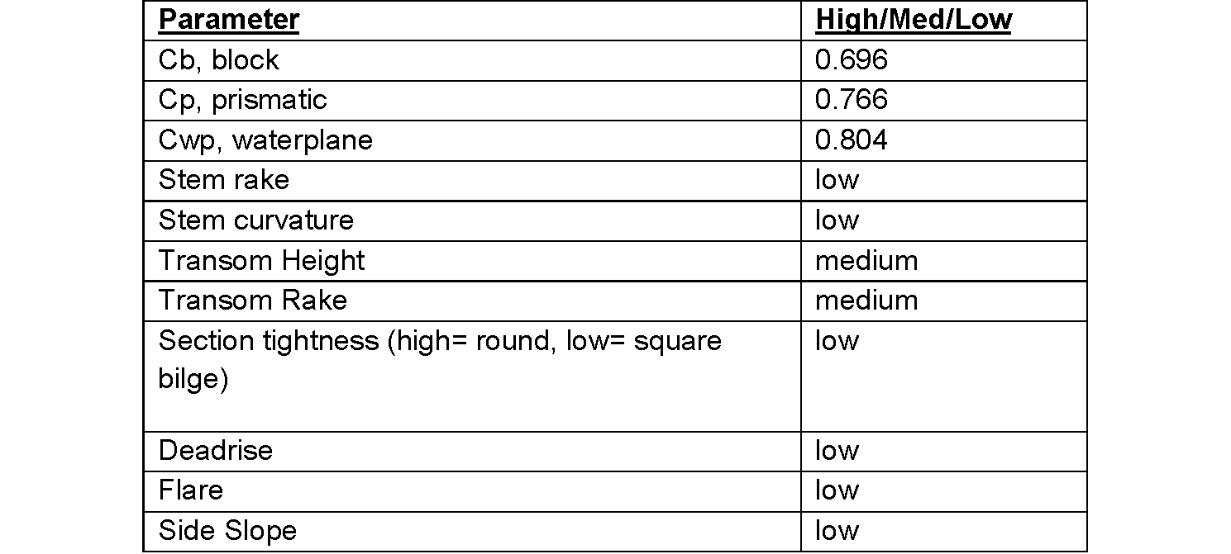
Table 4. AR-24 Hull Selection Parameters
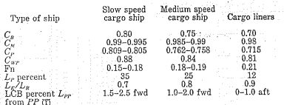
Table 5. Variation of Form Coefficients and Elements of Hull Shape, (Principles of Naval Architecture Volume II) Based on Lindblad (1961) and Todd (1945)

The AR-24 will be a monohull design. All currently operational and past tenders in U.S. Navy use have been large displacement monohull vessels. Furthermore, a multi-hull design will lack the necessary interior volume to hold the variety of workshop spaces as well as the weapons storage. The AR-24 will be a displacement hull based on the speed regime which it will fall in and the size and weight of the ship.
The AR-24 is a displacement vessel with a Froude number of 0.28 at top speeds (20 knots), and a Froude number of 0.168 at a cruising speed (12 knots). The equation used to determine these values is where V is the speed in ft/s, g is gravity, (32.2 ft/s²), and L is length overall, (450 ft). The Froude number at cruising speed shows that the AR-24 will be in the same speed regime as a slow-moving cargo ship (Morabito & Falls, 2019). Two propulsors were used on this ship design to support efficiency and redundancy.
The AR-24 has straight box shaped sides optimized for internal volume like those of a medium speed cargo ship. While the aft of the AR-24 is not similar to these vessels hulls, the shape is informed by the existing hulls of naval auxiliaries, particularly tenders.
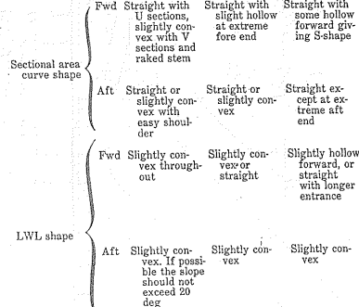
Table 6. Variation of Form Coefficients and Elements of Hull Shape, (Principles of Naval Architecture Volume II) Based on Lindblad (1961) and Todd (1945)

Load Line Freeboard and Bow Height
Using the formulas outlined in the International Conference on Load Lines, 1966, Regulation 39. The minimum bow height required was calculated to be 4.909 meters. Using the adapted summer freeboard graph, it was determined that the AR-24 requires a minimum of 72 inches of freeboard.

To calculate this, the following calculation were used:

$F_{b}=(6075 (L/100) -1875 (L/100)^{2}+200(L/100)^{3})* (2.08+0.609Cb -1.603C_{wf}-$ $0.0129(L/d_{1})$

Where the given value for length was 450 feet and length at waterline (LWL) was 406.5 feet. To use the equation, length was required in meters therefore L=118.945 m. The given block coefficient of the ship was 0.72. To calculate the waterplane coefficient the following equation was used.

$C_{wp}=A_{wf} /\{(L/2) *B\}$

Where $A_{wf}$ is the waterplane area forward of L/2 at $d_{1}$and $d_{1}$is defined using the equation
$d_{1}=D*0.85$ where D is draft in meters. Using the initial value for draft of 20.46 feet, the value for $d_{1}$ is 5.7m. $A_{wf}$ is calculated using the equation:

$A_{wf}= (L/2)(d_{1})(0.72)(0.871)$

$A_{wf}$ was calculated to be 212.589 m². Using this value and a beam (B) value of 18.288m, the $C_{wp}$was calculated to be 0.195. The minimum bow height required was calculated to be 4.909 meters, or 16.02 feet. $F_{b}$ was calculated using all of these values to equal 4.909m as the amount of freeboard which the ship has. The required amount of freeboard for the ship is 1.83 meters.

Using the adapted summer freeboard graph it was determined that the AR-24 requires a minimum of 72 inches of freeboard. This number was then corrected using the correction equation:
$FBD_{Corr}=FBD*\frac{(C_{b}+0.68)}{1.36}$

Because the ship also satisfied D > L/15 the following correction was added:
$Additional Correction=3*(D- \frac{L}{15})$

With the addition and corrections, the required freeboard was calculated to be 149.11 inches, or 12.42 feet. Using the Rhino models, the actual values of this were done. Table 4 outlines both the bow height and freeboard requirements as well as the ship's values.

 | Required Value | Ship’s Actual Value
Bow Height | 16.02 ft | 37.5 ft
Freeboard Height | 12.42 ft | 43 ft
Table 7. Bow and Freeboard Height Requirements
Using this table, it is clear that the AR-24 Valkyrie satisfies these requirements for both minimum bow height and freeboard.

Curves of Form
The Curves of Form for the AR-24 were generated in Rhino and correlated in Excel thus producing the Curves of Form graph below in Figure 14. The waterplane area of the ship dramatically changes at a draft of 32 ft because the transom enters the water at this draft.

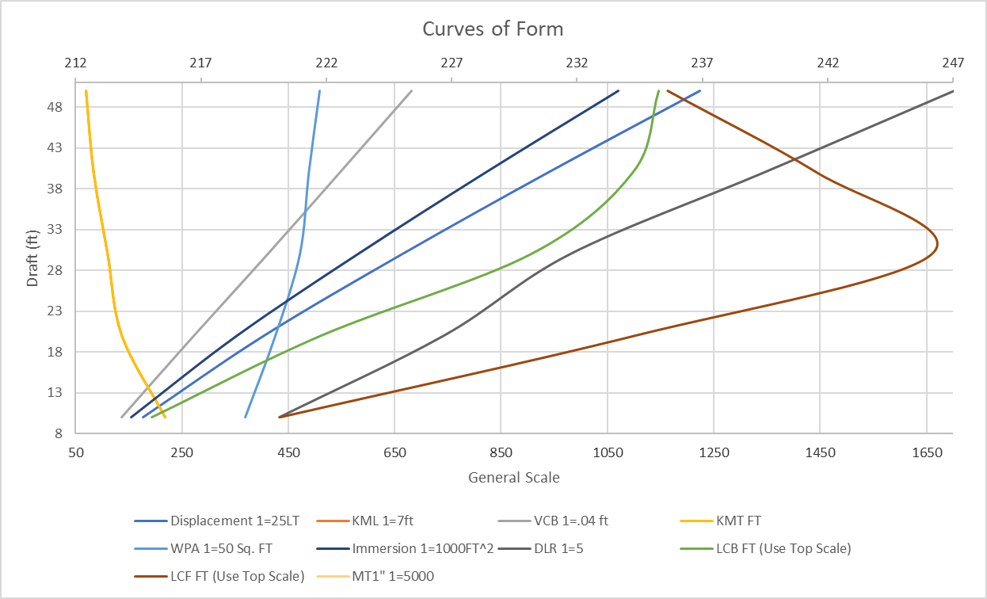
Figure 14. Curves of Form

Floodable Length Curve
This curve gives initial floodable length for margin line submersion. This shows a floodable length of 270 ft at 95% permeability; over 50% of the ship’s length. This will decrease as requirements from DDS 079 are considered, however the number of compartments should easily account for these changes. Figure 15 shows the floodable length indicated without the triangles.

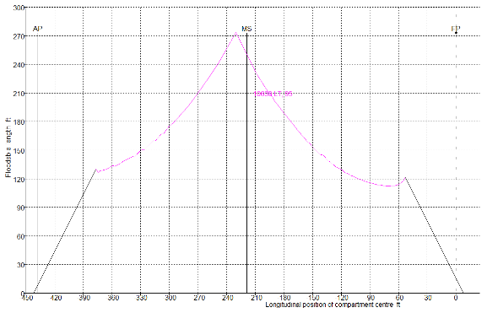
Figure 15. Floodable Length Curve without Triangles
Figure 16 shows the floodable length indicated with the triangles denoting a three-compartment standard. The thick black lines denote spacing for watertight bulkheads separating the compartments. Throughout much of the ship, there remains room below the curve to include safety and redundancy for partial flooding and other damage. This is also helpful in the event of changing bulkhead locations in future iterations.

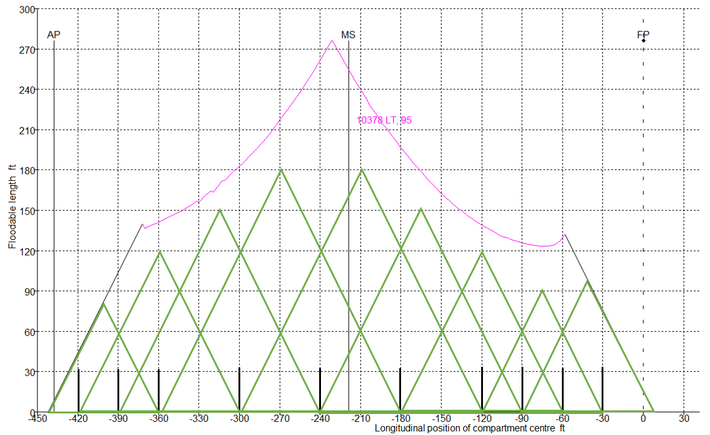
Figure 16. Floodable Length Curve for 95% Permeability

Area and Volume Summary
Table 8 provides a comprehensive summary of the area and volume of each level and deck on the AR-24 Valkyrie.

Deck/Level | Area (ft^2) | Volume (ft^3)
02 Level
01 Level
Main Deck
1st Deck
2nd Deck
3rd Deck
Bilge Deck
Table 8: Deck and Level Areas and Volumes

Structural Design

Load Plate Structural Analysis
A local plate structural analysis was performed using the code outlined in 3.15 Bottom Shell Plating Amidships rules laid out by the American Bureau of Shipping Rules for Building and Classing Marine Vehicles, Section 3-2-2.
In Rule 3.15.1 the shell plating thickness for longitudinal framing was calculated to be 0.479 inches thick. Rule 3.15.2 outlines the minimum bottom shell thickness which was calculated to be 0.423 inches thick. Based on this information, the AR-24 Valkyrie will be built with 0.5-inch-thick plating for the hull. Table 9 outlines variables used in these calculations.

Variable | Value
s (for 3.15.1) | 28.1063 in.
L | 434.25 ft.
ds | 36.85 ft
Ds | 55 ft.
s (for 3.15.1) | 24.7335 in
Table 9. Load Plate Analysis Variables
Using ABS rules, for load plate analysis a stillwater moment of 10,000 LT-ft is assumed with a wave hogging moment of 14,000 LT-ft and a wave sagging moment of 900 LT-ft. A dynamic amplification factor of 1.5.

With the use of the material EH-36 steel there is a material yield of 51,000 pounds per square inch, an allowable factor of safety of 2, which leaves a material allowable of 25,500 pounds per square inch. The table below shows the overall material conditions, factor of safety and if they pass the factor of safety check.

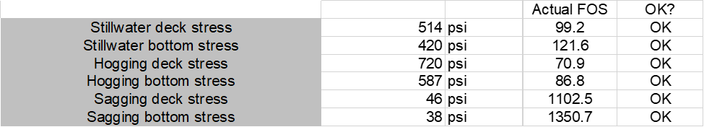
Table 10: Factor of Safety Check

Load Stiffener Calculation (One Bay)
Using ABS Rules, the section moduli for one bay were determined for the various sides of the bay (ABS, 2024).

Using Rule 3-2-4/11.3 the section modulus for the bottom and inner bottom longitudinal was calculated using the equation:
$SM=0.0041*chsl^{3} in^{3}$
Equation 1. Section Modulus for Bottom and Inner Bottom Longitudinals

The section modulus was 1.0506 in³ where the value of c was 0.715 (with effective struts). In addition, h was 2.8 feet, s was 2 feet, and l was 8 feet.

Using Rule 3-2-5/3.1 the section for the transverse frame was calculated using the equation below (ABS, 2024).

$SM=sl ×(h+ \frac{{bh}_{1}}{c_{1}})×(c_{2}+\frac{c_{3}}{l^{3}})×Q$
Equation 2. Section Modulus for Transverse Frame
For this equation, C1 = 100, C2 = 0.0037, C3 = 0.8, h1 = 43 + 0.0037 + 100 + 0.8, and Q = 0.68 for H40 strength steel as defined by rule 3-2-1/5.3 (ABS, 2024). The section modulus for the transverse frames was calculated to be 0.243 in3.

Using Rule 3-2-7/3.1 the deck beams and longitudinal section moduli were calculated using the equation below:

$SM=0.0041chsl^{2}$in³
Equation 3. Deck Beam and longitudinal Section Moduli
For this equation, the variable values are c = c₂. Additionally, the c₂ for transverse beams between longitudinal bulkheads is 0.54 and for beams between longitudinal deck girders is 0.585. The sectional modulus for transverse beams between longitudinal bulkheads is 0.3967 in³ and the sectional modulus for beams between longitudinal deck girders is 0.4298 in³.

Using Rule 3-2-9/5.3 the watertight bulkhead stiffener section modulus was calculated with the equation below:

$SM=0,0041kchsl^{2}$
Equation 4. Watertight Bulkhead Stiffener Section Modulus
For this equation, k = 1 for watertight bulkheads and c = 0.43 with stiffeners with effective brackets supported by girders or webs resulting in a section modulus of 0.6319 in³.

Finally, Rule 3-2-10/3.3 the deep tank bulkhead stiffener section modulus was calculated with equation 7.
$SM=0.0041chsl^{2}$
Equation 5. Deep Tank Bulkhead Stiffener
For this equation, c = 1 as it is supported by horizontal girders resulting in the section modulus of 1.4694 in³. All section moduli are summarized in Table 11.

Member | Value (in³)
Bottom and Inner Bottom Longitudinal | 1.506 in³
Side Frames | 0.243 in³
Transverse Beam Between Longitudinal Bulkheads | 0.3967 in³
Beams Between Longitudinal Decks | 0.4298 in³
Watertight Bulkhead Stiffeners | 0.6319 in³
Deep Tank Bulkhead Stiffeners | 1.4694 in³
Table 11. Section Modulus Summary

Global Bending Analysis
Following the American Bureau of Shipbuilding rules, a global bending was conducted which resulted in the stresses outlined in Table 12.

 |  |  | Actual FOS | OK?
Stillwater deck stress | 249 | psi | 320.9 | OK
Stillwater bottom stress | 617 | psi | 129.6 | OK
Hogging deck stress | 349 | psi | 229.2 | OK
Hogging bottom stress | 864 | psi | 92.6 | OK
Sagging deck stress | 22 | psi | 3565.3 | OK
Sagging bottom stress | 56 | psi | 1440.1 | OK
Table 22. AR-24 Structure Global Bending Analysis

Hull Section Modulus
The required total section modulus for the AR-24 Valkyrie is 1,659, 511 cubic inches and the total section modulus using the hull section modulus spreadsheet is 1,745,497 cubic inch calculation for this can be found in the following tables, all tables are in the USCS measurement system and assume a height of deck of 660 inches.

Table 13 shows the major plating components for one half of the midship section. No collision plating was used in the major plating as it was not required by the ABS rules, however, this could be a consideration in the future given the nature of the AR-24 Valkyrie. To protect the ship from customer ship damage, fenders will be used.

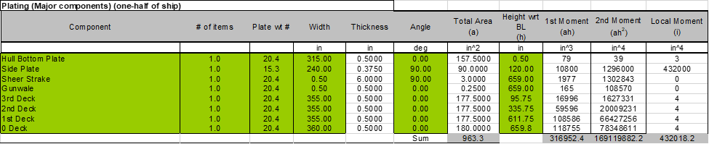
Table 13: Major Plating Components
Table 14 details the longitudinal small-components for one half of the midship section.

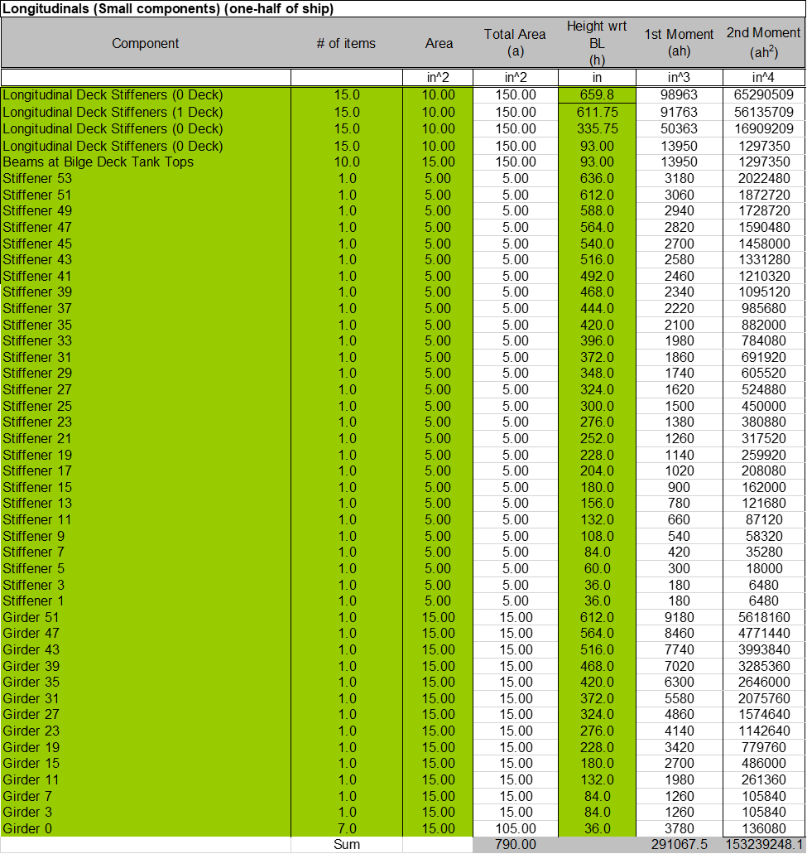
Table 14: Longitudinal Components
The following table details the curved plating components for one half of the midship section and the total sums of area, first and second moments of inertia, and the local moment of inertia for all components of the structure in the midship section. Table 15 shows both the half-ship and full ship values as a result from all of the structural components in the midship section. Of note, the percent height of the neutral axis above the baseline is 45%, which is in line with the guidance for it to be as close to 50% as practical.

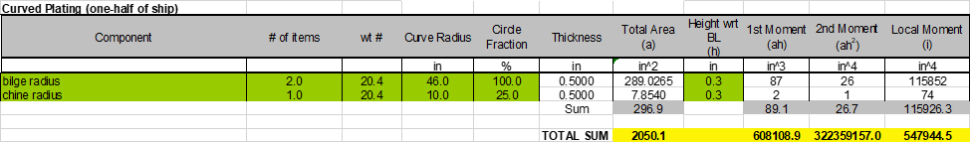
Table 15: Curved Plating Structural Support
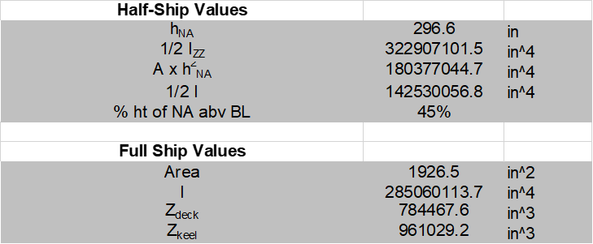
Table 16: Half-Ship and Full Ship Values
A drawing of the midship section can be found in Appendix 4.

Propulsion Trade-Off Study
The propulsion system for the AR-24 was designed for a maximum brake horsepower of 36,200. This includes the combined BHP at highest expected resistance and electrical loading. An engine configuration was settled on after considering max load and loading at design speed with average electrical load. The AR-24 will use four marine diesel 16V 8000 M71L MTU engines. These will combine into a double input reduction gear, powering the two shafts. This engine is typical for large displacement vessels and naval auxiliary vessels. Each engine is capable of providing a maximum of 9762 BHP. Below is a table of standard vendor catalog information for this engine.

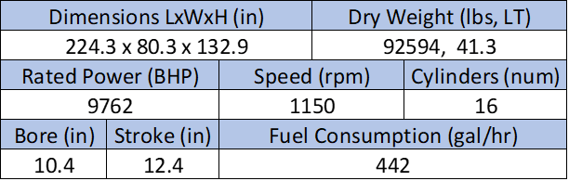
Table 17. Marine Diesel 16V 8000 M71L Engine Specifications
The manufacturing placemat is shown below (MTU Rolls-Royce, n.d.). This placemat notes that a common use for this engine is naval auxiliaries. While the AR-24 is not a high speed vessel, its horsepower requirements and electrical load requirements benefit from the power rating of the selected diesel engines.

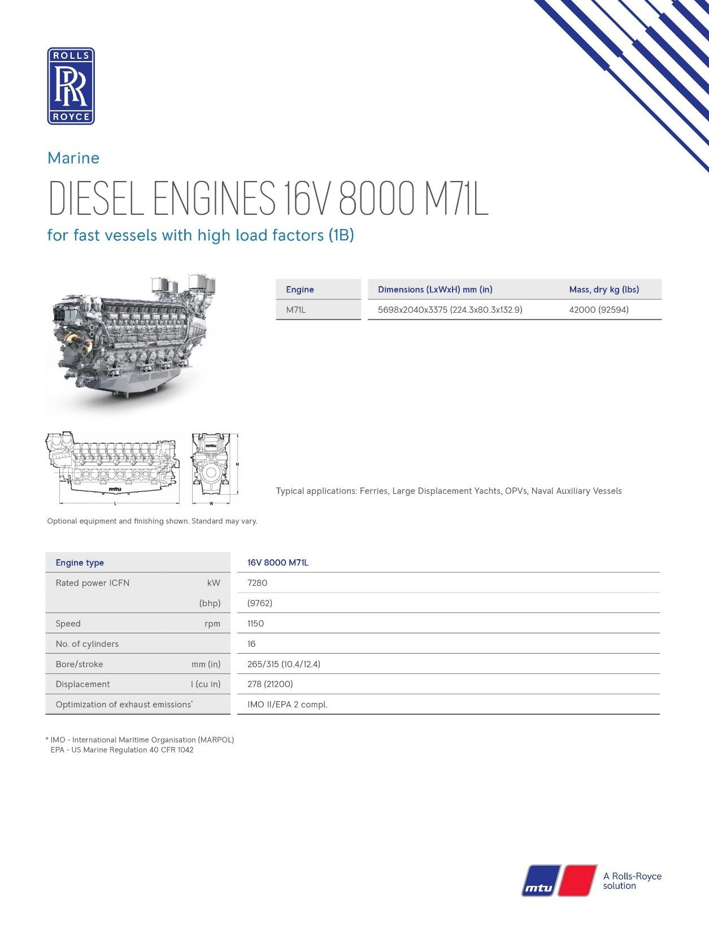
Figure 16. MTU 16V 8000 M71L Placemat
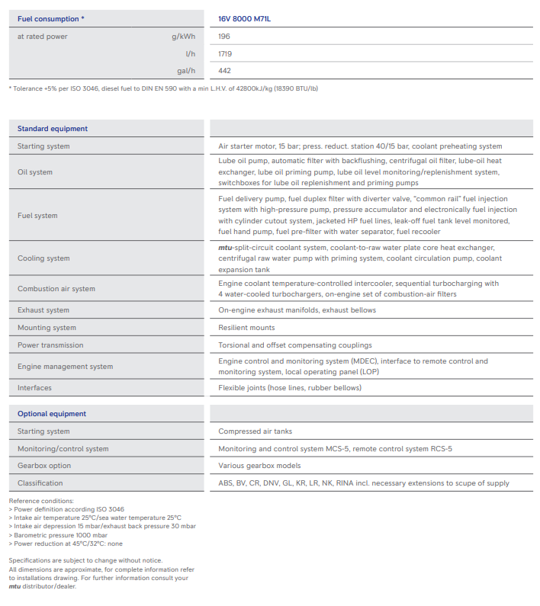
Figure 18. MTU 16V 8000 M71L Placemat

Specific Prop and Reduction Gear Selection
Propellers were designed to be optimized for the design speed of 12 kts. The thrust was modeled using the predicted resistance from section 7.1. The ship will have two identical propellers, rotating opposite of each other. A table with propeller dimensions and parameters is shown below, along with the open water curve and computer model of the propeller. The propeller was most optimized at this size and number of blades. This diameter will allow them to easily fit under the ship without potential of grounding, while still allowing ample room for a rudder. There will be 1.65 ft of clearance above the blade and 5.2 ft between the bottom of the blade and the bottom of the keel. There is 39.9 ft between the propeller and the transom to fit the rudder. The low RPM value is expected for the required power and will require a reduction gear ratio of 1:11.5. The number of blades is fewer than expected but was found most efficient. Parametric analysis and design was performed using a matlab modeling script, “Openprop” for propeller design. This was designed to optimize a B-series propeller, and this propeller falls into the B-series criteria shown below. Cavitation was checked using the Keller Equation shown below. The efficiency curve shows some increased efficiency at higher J values which suggests a lower trade off for operating at higher speeds than was initially expected.

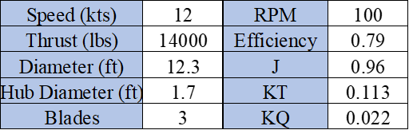
Table 18. Propeller Parameters Optimized for Design Speed
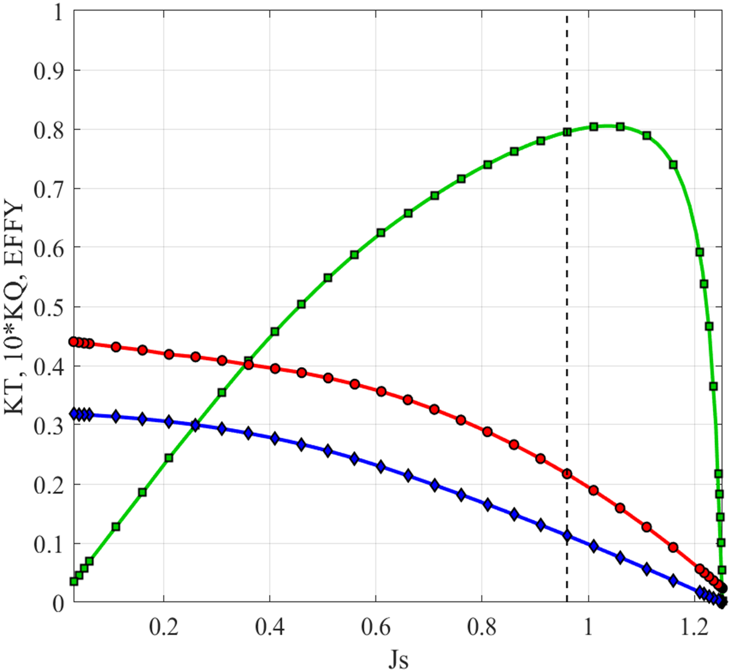
Figure 179. Propeller Design Open Water Curves

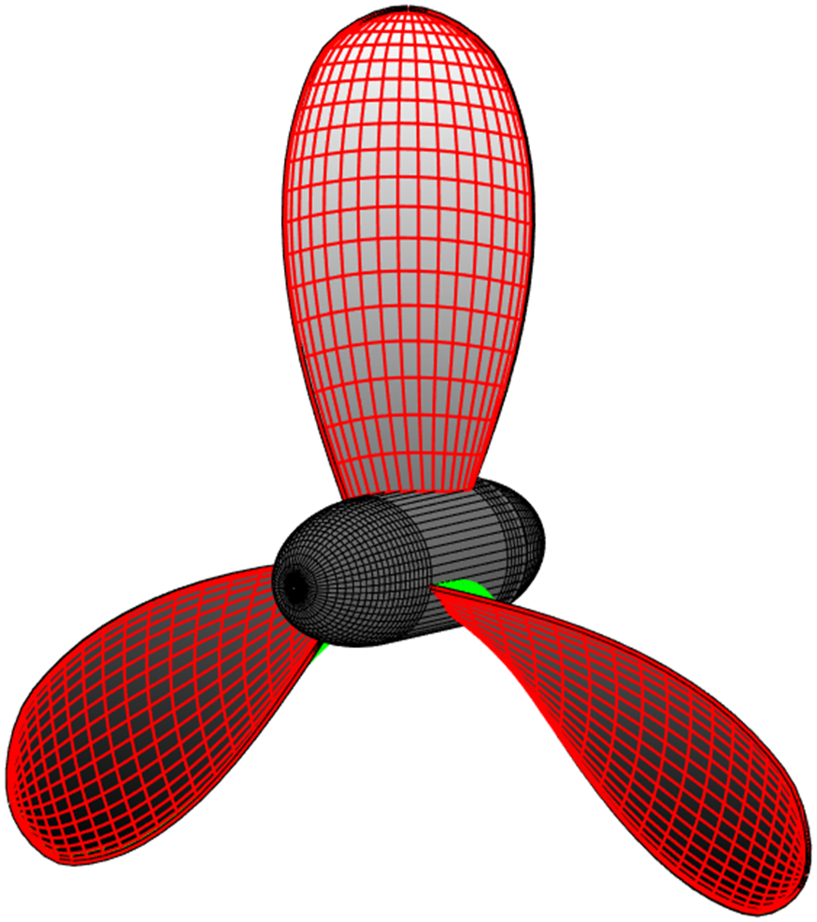

Figure 180. AR-24 Propeller Design
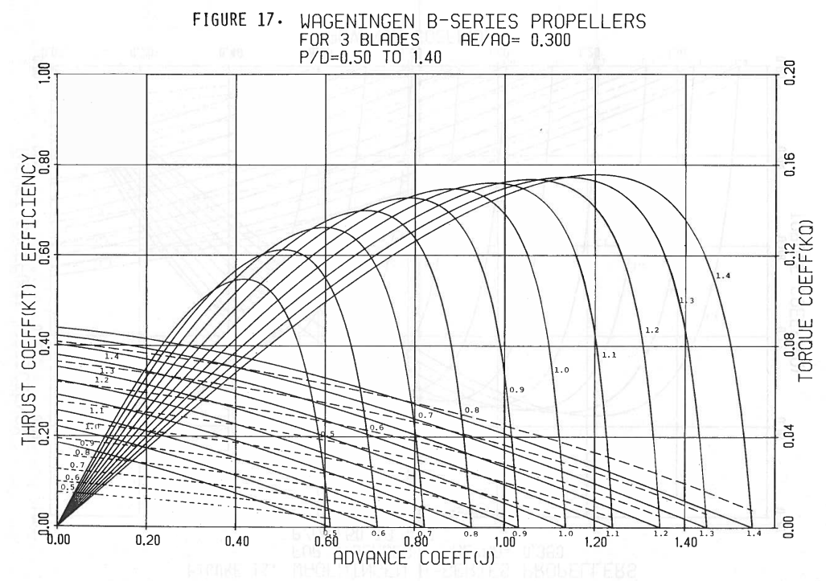
Figure 21: B-Series Open Water Curves
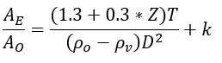
Equation 1: Keller Equation

Electrical Load Analysis and Sizing
The AR-24 electrical load analysis was performed at a high concept level. Effort was taken to ensure that emphasis was placed on systems contributing to the primary mission of AR-24, at sea repair to support battle damage repair and assessment at sea and at anchor. As such, the majority of the detail in the analysis was focused on the needs of supporting customer vessels (DDG-125 type) shore power requirements and repair division needs. This focus followed discussions with multiple EDOs and former repair department officers on AS-39 and AS-40 (USS EMORY S. LAND and USS FRANK CABLE). Additionally, there is an increase in critical auxiliary subsystems such as cooling pumps and air compressors to offset a design flaw in current operational tenders. Current tenders have little redundancy in auxiliary systems meaning minor system failure can impede the operational availability of the vessel to combatant commanders.

The electrical load analysis is, as expected, significantly higher in the at anchor condition. In this condition, the electrical load is higher both due to an increase in the expected percentage of capital repair equipment in operation and the need to provide shore power to two DDG-125 customer vessels. At sea, the requirements for the AR-24 are reduced as less repair division capital equipment is in use. The table below shows the estimated expected electrical load analysis.

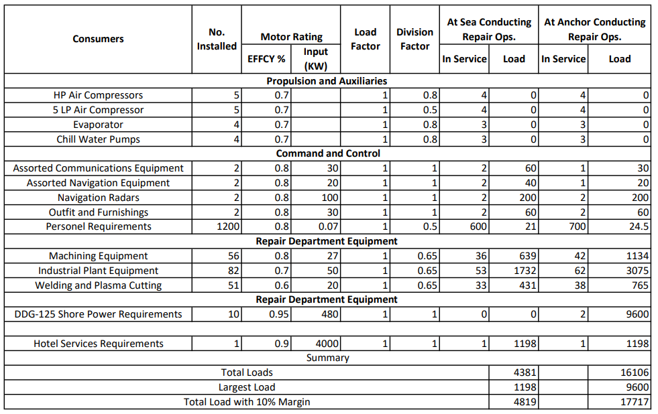
Table 19. Electrical Load Analysis (kW)

H,M, & E Systems

Main Machinery
Figure 22 shows the preliminary machinery spacing layout including electrical and auxiliary considerations.
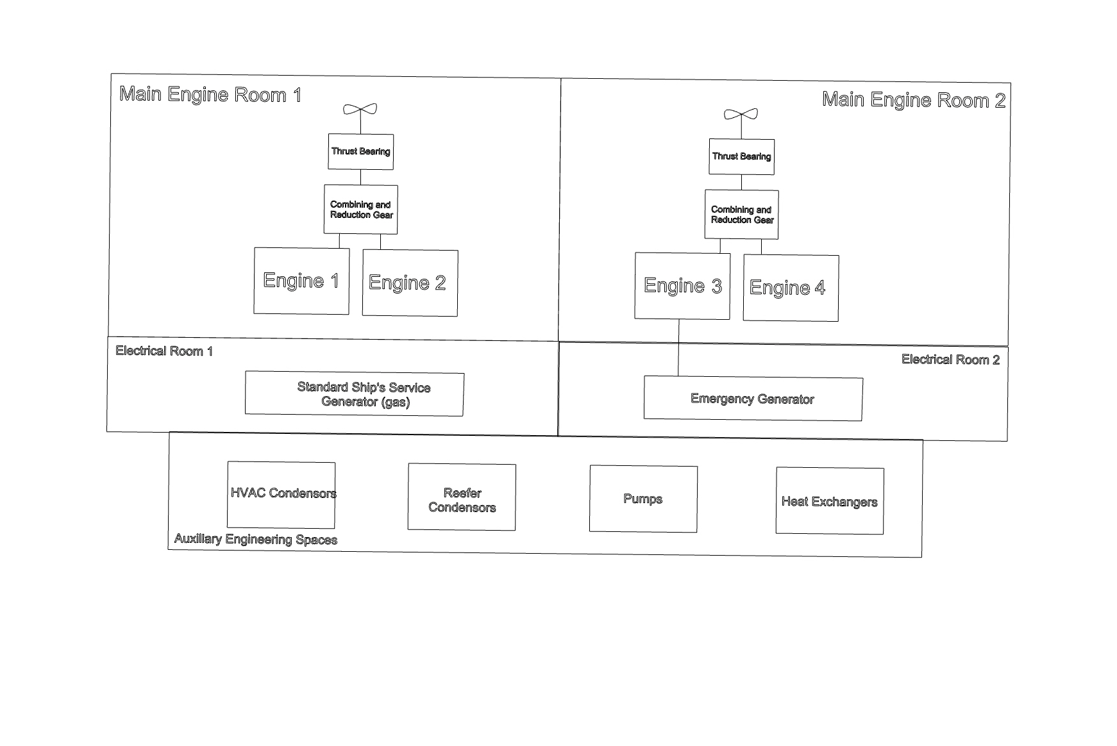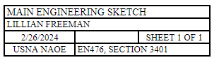Figure 22. Machinery Space Sketch

Piping Systems
Figure 23 shows the preliminary piping one-line sketch for the seawater cooling system for all HVAC Condensers, Refrigeration Condensers, and Freshwater Cooling Systems.

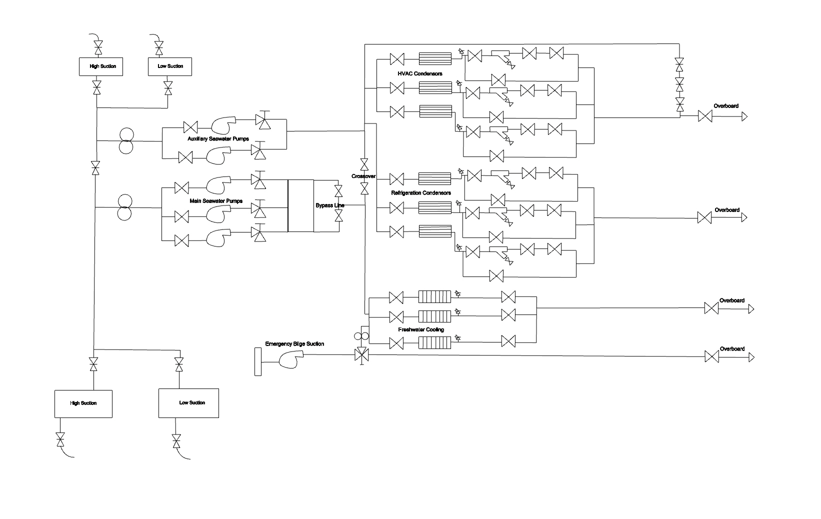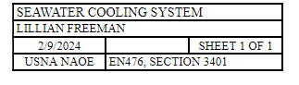Figure 23. Seawater Cooling System Piping Schematic

Figure 24 shows the preliminary piping one-line sketch for the CHT system.
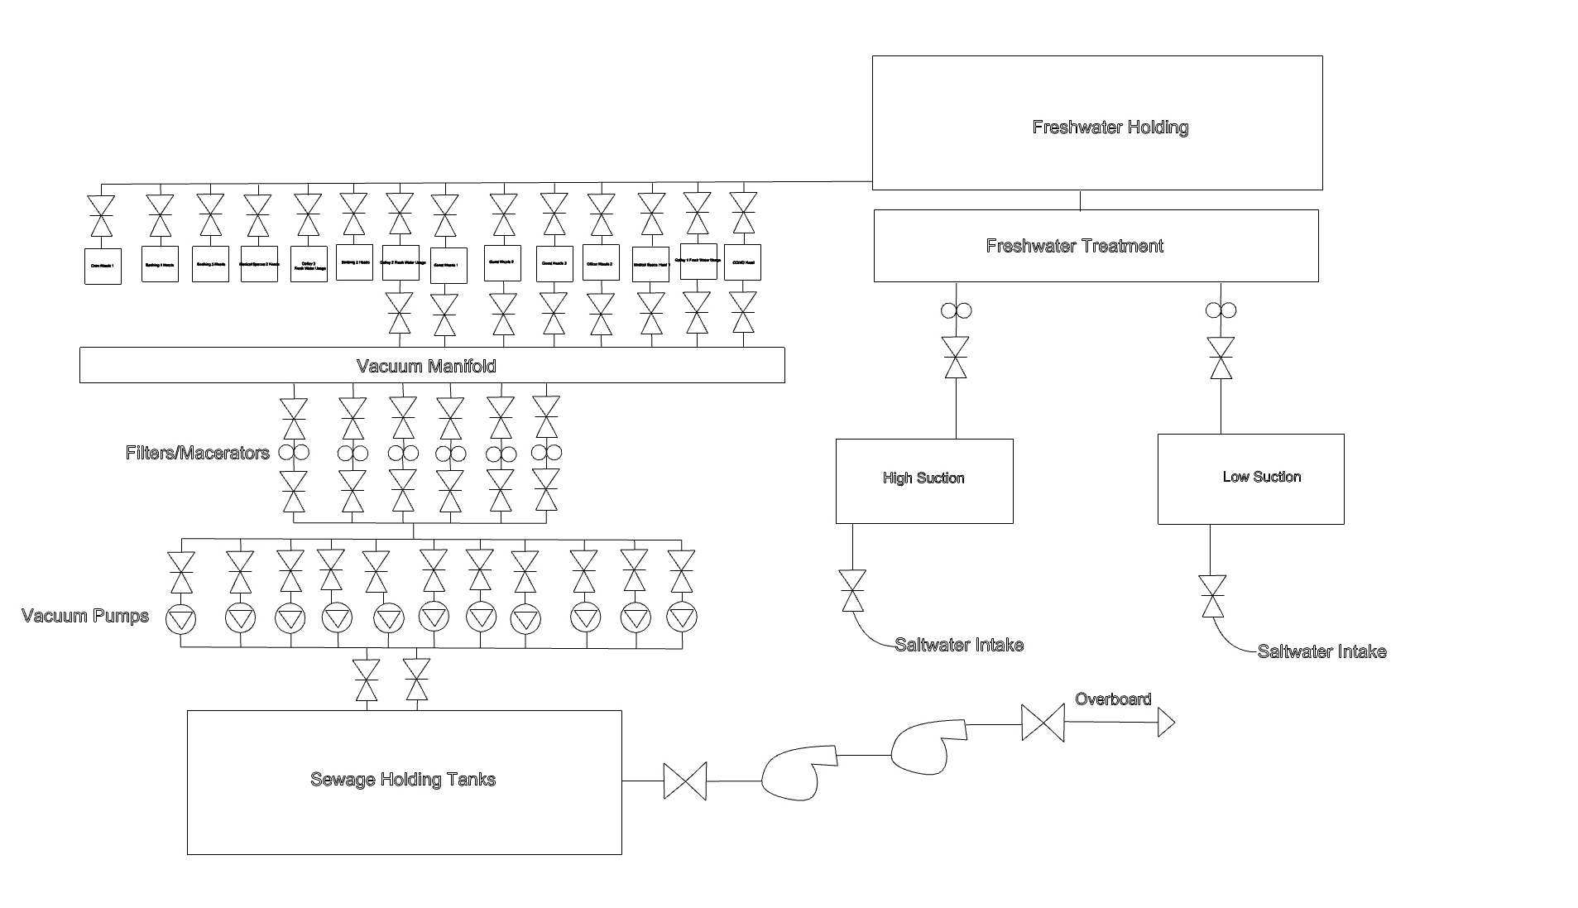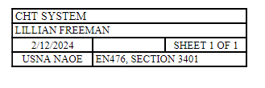

Figure 19. CHT System Piping Schematic

Figure 25 shows the preliminary one-line piping schematic for the hydraulic fluid and oil system.
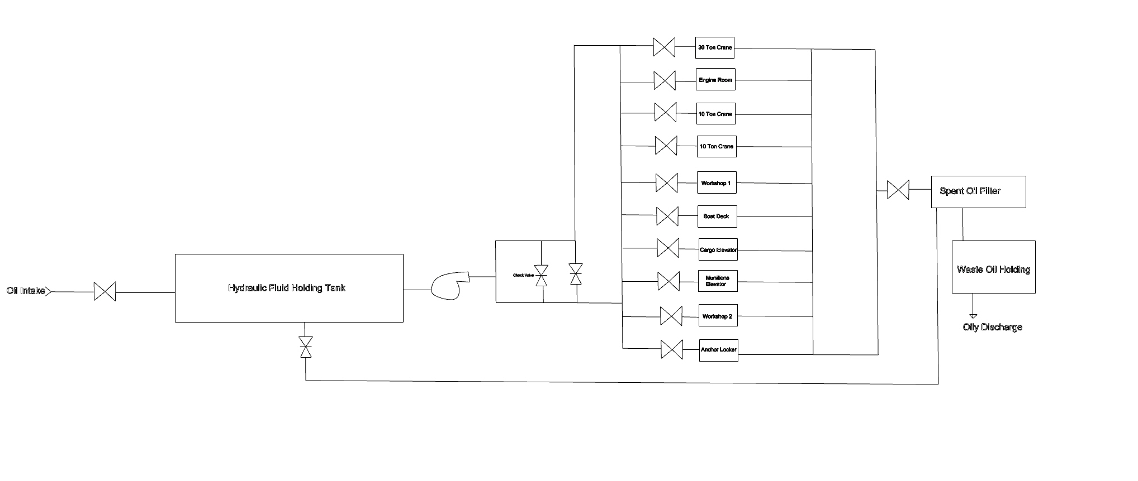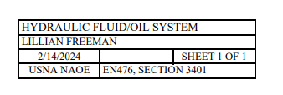

Figure 220. Hydraulic Fluid and Oil System

Electric Generation System

Figure 26 shows the preliminary one-line piping schematic for the electric generators onboard the AR-24 Valkyrie.

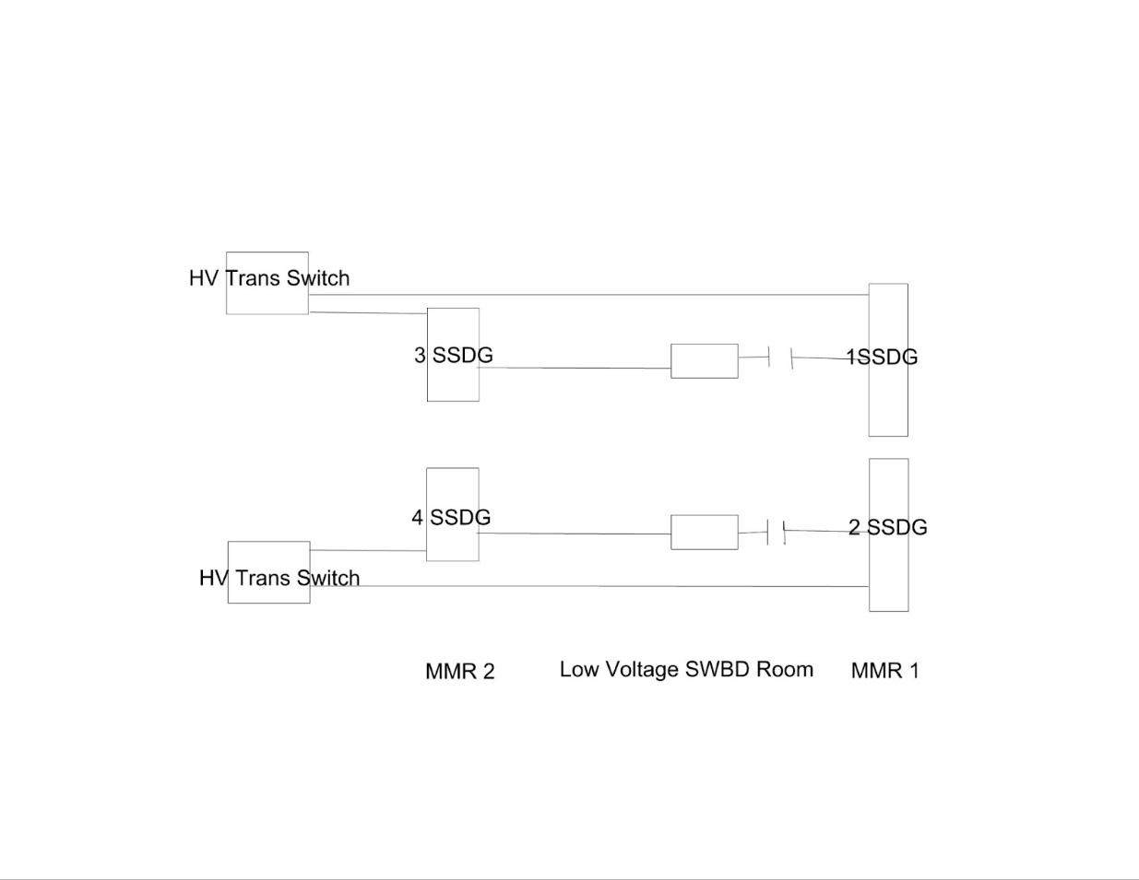
Figure 21. AR-24 Electrical Generation One Line Diagram

Mission-Related Systems

Overhead Rail System
Due to the nature of the large machinery aboard the AR-24 Valkyrie and the large items required to be moved around the ship, an overhead rail system will be used. An overhead rail, or monorail system can transport heavy-duty repair materials and weapons to many locations on a ship that would otherwise be too difficult to move with manpower alone. This system would have the capacity of 6,000 pounds and be similar to systems used on the USS MCKEE and other repair tender ships. Features of this system include the capability to move materials and machinery to machine shops to elevators and a chainfall system to move materials to various decks.

Defensive System
As the AR-24 Valkyrie is a US Navy non-combatant ship it is important that it has some measures by which it can defend itself. While past repair tenders rely heavily on a five-inch gun for defense, the Phalanx close-in weapon system (CIWS) more adequately supports defense in the modern maritime combat picture. The CIWS system features 6 barrels, with a 20 x 120mm tungsten Armor-piercing discard sabot and is capable of rotating 150 degrees from either side of the ship’s centerline. The CIWS is best for air and missile defense with an effective firing range of 1,625 yards and a maximum firing range of 6,000 yards. (Wikipedia).

Dive Operations and Underway Husbandry System
To support both dive operations and underway husbandry the AR-24 Valkyrie has a dive boat located on the centerline of the ship. Based on field research with the Mid-Atlantic Regional Maintenance Center, it was determined that undersea medical support is necessary to include onboard the Valkyrie to include sufficient medical spaces to treat common dive related sicknesses and injuries as well as a transportable compression chamber with the ability to be stowed on deck. The ship will use its organic crane assets to support these systems.

Margin for Future Industrial Technologies
Due to the developing technologies in the Navy, there will be some spaces onboard that are flexible to add the margin of additive manufacturing spaces and a composites shop for future vessels and hull repair shops that are integral for structural work,

Weight Estimate
Using parametric analysis and space and weight data from the parent hull, the ex-McKee (AS-41), as provided by Naval Sea Systems Command. Table 20 shows the dimensions of both the parent and new design.

PRINCIPAL CHARACTERISTICS
DATA |  | UNITS | PARENT | MY HULL
LOA |  | ft | 644 | 450
LBP |  | ft | 600 | 440
B @ DWL |  | ft | 85.00 | 60.00
T (molded) |  | ft | 26 | 24
D |  | ft | 62.7 | 55
Installed HP |  | Hp | 20,000 | 36,200
Kw |  | Kw | 14,914 | 14,000
Accommodations |  | # | 1200 | 933
Endurance |  | days | 60 | 30
Cubic Number |  | (LBP*B*D)/100 | 31977 | 14520

Table 20. Parent and New Design Dimensions
Table 21 shows the breakdown of variable loads included in the design of both the parent and new design.

VARIABLE LOADS
ITEM | UNITS | PARENT | MY SHIP | REFERENCE
Cargo | LT(SW) | 700 | 600 | Estimate
People & stuff | LT(SW) | 160.7 | 125.0 | 300 Pounds per person
Stores & Prov | LT(SW) | 357.6 | 139.0 | USN with 10% margin
Fuel | LT(SW) | 80 | 80.0 | Estimate
Water | LT(SW) | 23.21 | 25.0 | Estimate
Misc & Ballast | LT(SW) | 66.1 | 48.4 | 5% of abv loads (estimate)
TOTAL PAYLOAD | LT(SW) | 1387.6 | 1017.4 | LT(SW)

Table 21. Parent Hull and AR-24 Design Dimensions
To further illustrate the breakdown of weights, Figures 22 and 23 show both the Lightship and
Full Load conditions and what percent of the weight breakdown looks like compared to others.

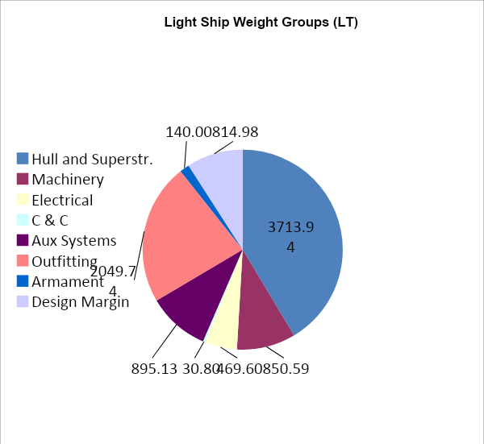
Figure 27. Light Ship Weight Groups
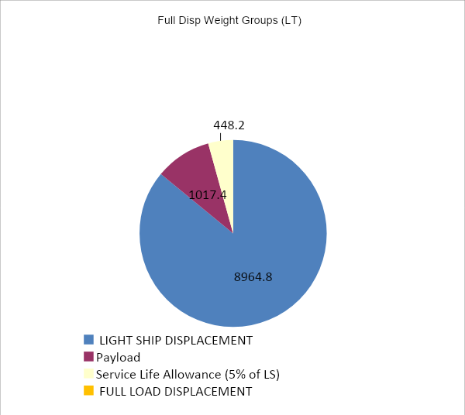
Figure 28. Full Displacement Weight Groups

Trim and Intact Stability Analysis
The stability curve above shows the vessel has strong stability, with a maximum righting arm of 10.528 ft and a maximum righting moment of 109156 LT-ft at an angle of 70 degrees. It will experience deck edge immersion slightly beyond 50° of heel and down flooding after 110°.

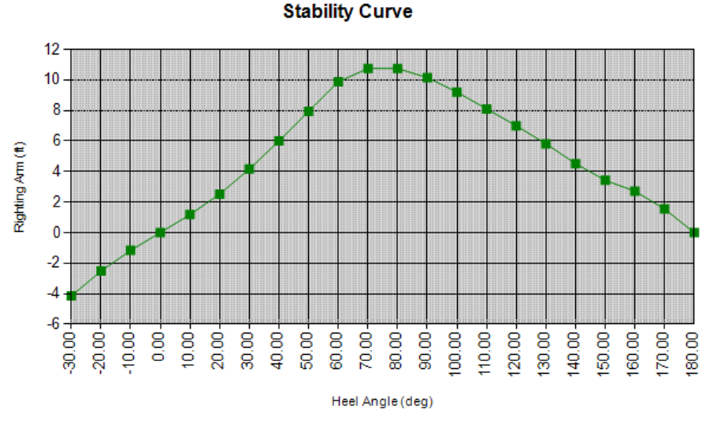 Figure 29. Full Load Intact Stability Curve for -30° to 180°
The ship is stable in lightship conditions, with a maximum righting arm of 20.288 ft and a maximum righting moment of 184,032 LT-ft at an angle of 80 degrees. After 55° of heel, the ship will experience deck edge immersion and begin down flooding after experiencing heel angles of 110°, similar to full load conditions.
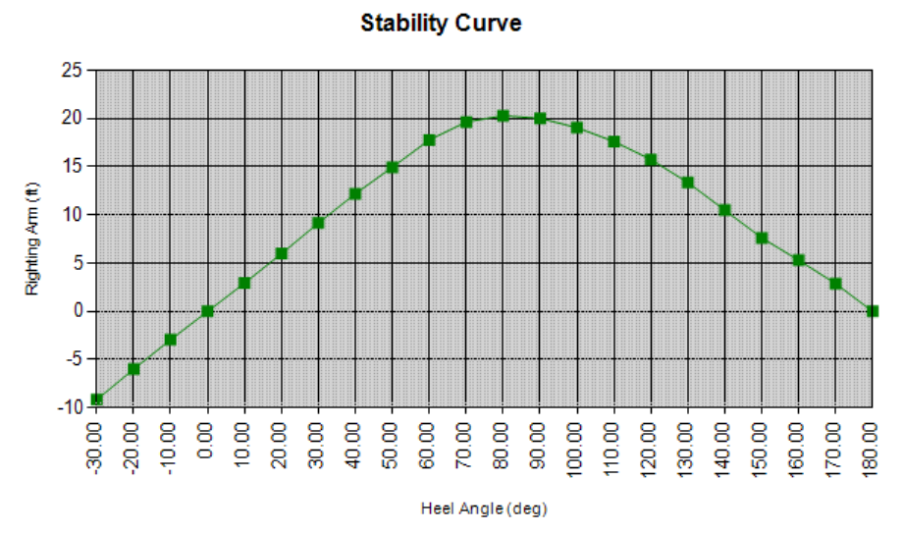
Figure 220. Lightship Intact Stability Curve for -30° to 180°
The stability curve above shows the vessel has stability for burnout conditions, with a maximum righting arm of 10.939 ft and a maximum righting arm of 108,219 LT-ft at 80 degrees. Deck edge immersion will begin at just over 50° of heel and down flooding will begin after 110°. In regards to righting moment, the ship has positive stability through 180 degrees of heel for all modeled conditions. Each condition was modeled based on criteria laid out in Section 4.3.
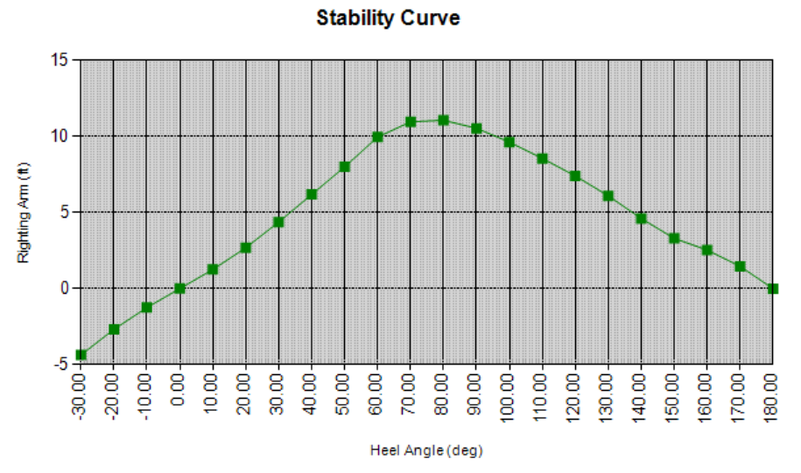
Figure 231. Burnout Intact Stability Curve for -30° to 180°

Speed-Power Analysis

Holtrop Speed/Power Analysis
Using the Orca3D plugin in Rhino7 software, a Holtrop speed/power analysis was conducted. This resulted in initial estimates for the resistance prediction of the AR-24 hull. A Holtrop analysis was appropriate for AR-24 as the hull met all requirements for the analysis as outlined in Table 22.

Parameter | Value | Minimum | Maximum | Type
Cp | 0.619 | 0.55 | 0.85 | OK
L/B Ratio | 7.775 | 3.9 | 14.9 | OK
Lamda Coef. | 0.662 | 0 | 0.99 | OK
B/T Ratio | 2.83969 | 2.1 | 4 | OK

Table 22. AR-24 Hull & Holtrop Analysis Criteria

Series Selection
The Taylor-Gertler series was selected due to its applicability to the AR-24 class. Both are applicable to displacement monohulls and while the AR-24 does not have a cruiser stern, the applicability of the series is still valid. It is also a large displacement hull and is a single screw vessel (Taylor & Gertler, 1954). The AR-24 hull form was analyzed for resistance calculations using Taylor Series analysis.

Taylor Series Resistance Estimate
To calculate the resistance, the Residual Resistance Coefficient was drawn from the diagram in figure 16. The Froude number for each speed was used on the x-axis. The y-axis trendline was determined by calculating the volumetric coefficient using Equation 3 (Taylor & Gertler, 1954).
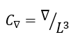
Equation 7: Volumetric Coefficient
Using the volumetric coefficient and Froude number, the residual resistance coefficient at 18 knots was calculated. Once the residual resistance of the hull was derived from the Taylor Series Diagram, the AR-24’s frictional resistance was calculated using the 1957 ITTC Line (International Towing Tank Conference, 2011).
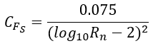
Equation 8. 1957 ITTC Line
The total resistance coefficient was calculated. Using $C_{T_{S}}$ , the total resistance of the ship is calculated. Equations 4, 5, and 6 are taken from the Taylor-Gertler Series (Taylor & Gertler, 1954).
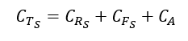
Equation 9. Taylor Series Total Ship Resistance Coefficient
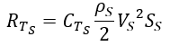
Equation 10.Taylor Series Total Ship Resistance
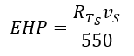
Equation 11. Taylor Series EHP of Ship Calculation
The EHP estimated at 18 Knots (the maximum design speed) using the Holtrop method is 7,886 horsepower. This is similar to the Taylor Series EHP estimation, 7794 horsepower. The two estimates are less than 20% apart, an acceptable variation considering the hull differences between the Holtrop and Taylor series. The variation can be explained by the difference between the Holtrop and Taylor models, especially the Taylor Model’s cruiser stern, single screw, and bow shape. The AR-24 has two screws and does not have a cruiser stern. However, the AR-24 and Taylor Series hulls at larger block coefficients share many characteristics.

BHP Prediction
Using the EHP estimates, the brake horsepower (BHP) estimate was calculated using Equation 12.
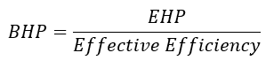
Equation 12. Taylor Series BHP Calculation
The BHP was calculated for both the Holtrop and Taylor Series EHP. The BHP efficiency considers the efficiency of the whole drivetrain from the shaft exiting the engine to the propeller. The BHP is calculated using the following equation:

$P_{B}=2π*M_{B}*n_{e}$
Equation 14. BHP Equation

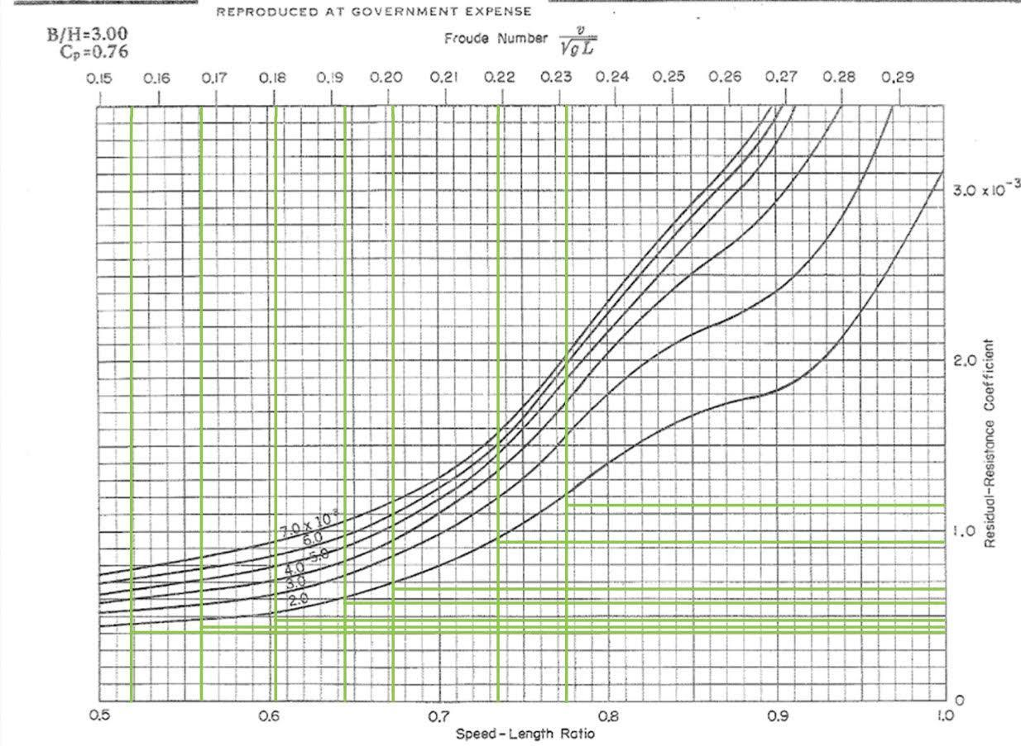
Figure 32. Taylor Series Estimates at $\frac{B}{H}=3.00$ and $C_{P}=0.76$
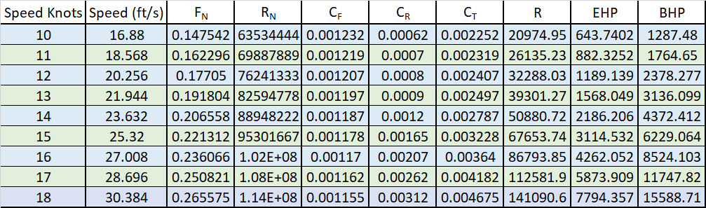

Table 23. Taylor Series EHP and BHP Estimate Results for AR-24 Hull Form

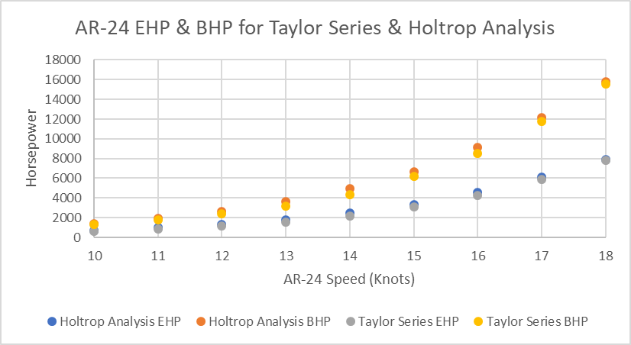
Figure 33: AR-24 Taylor Series & Holtrop Resistance Estimates for EHP and BHP

A model of AR-24 Valkyrie was tested in the USNA Hydrolab. Testing results were expanded and can be seen in Figure 47. Of note, there were three outlying data points, all based on tow tank runs in which multiple speeds were executed in a single run. When these speeds were rerun, the data was consistent with that which was expected. A hump and hollow was identified in the data between speeds of 13 and 15 knots (when expanded). This was determined to be a result of the transom drag which occurs at that speed. Resistance testing was considered to be a success as the results fell in the range as expected by the Taylor Series and Holtrop Analysis.

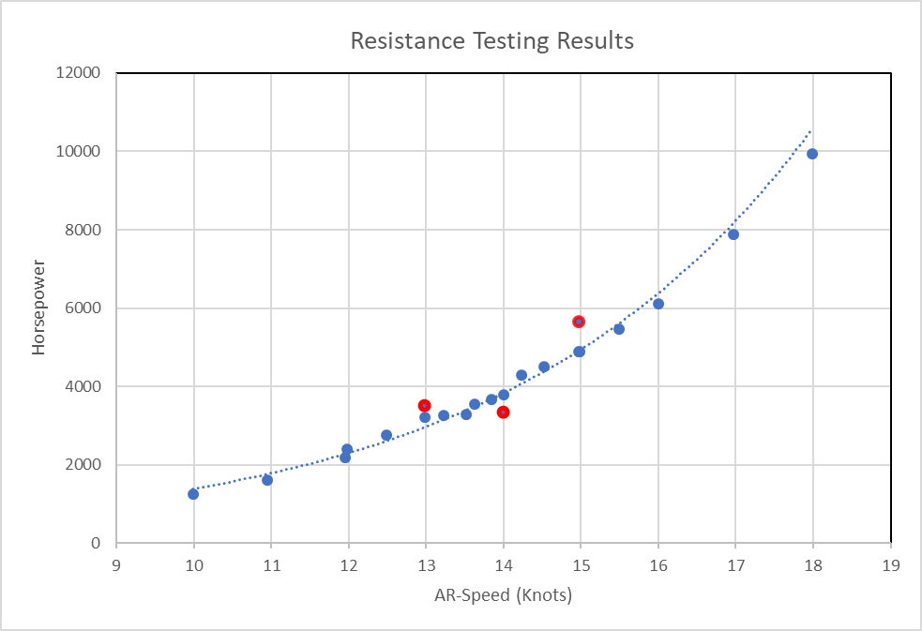
Figure 34: Resistance Testing Results (Expanded)
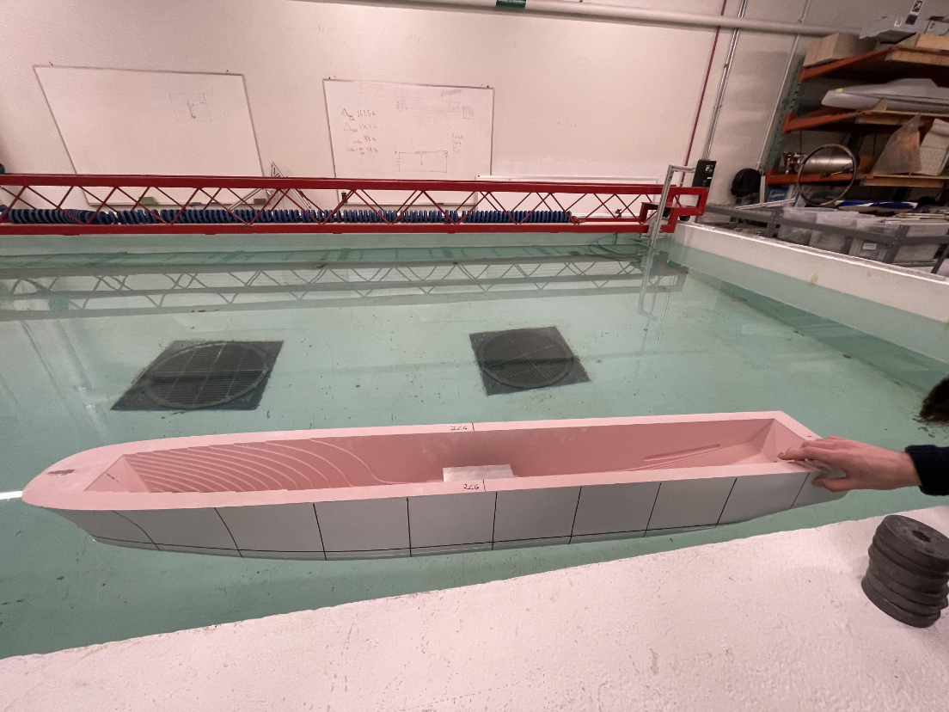
Figure 35: Hydrolab Testing

Endurance Calculation
For the endurance calculation, the fuel was the largest consideration. Fuel is the largest liquid by volume stored on the AR-24. Appropriate tankage was needed to ensure the AR-24 was able to have sufficient fuel to meet its mission profile. Figure 36 shows the AR-24’s design reference mission. Table 24 shows the calculated fuel volume requirements. AR-24 requires 104409.5 cubic feet of space for its mission profile. The AR-24 has sufficient tank capacity with 113216 cubic feet of space for fuel required.

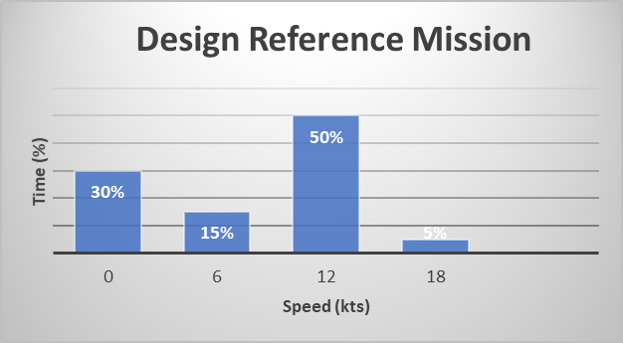
Figure 36. Design Reference Mission

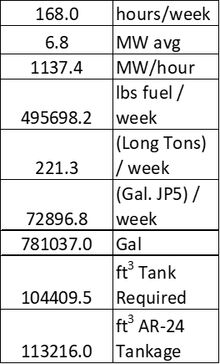
Table 24. Fuel Volume Requirements
The MW avg for the AR-24 is used to calculate the fuel consumption per MW/hour required for the Mission profile. Pounds of fuel per week is used to determine the volume in gallons using a density unit conversion.

Seakeeping Analysis
Seakeeping polar plots were created based on sea states four and five from the ITTC standard. The ship was modeled from 6 knots to the top speed of 18 knots with wave encounter angles from 0 to 180 degrees. Angles from 180 to 360 degrees were not included due to the symmetry of the ship. It was considered to be at full load conditions for all tests. Roll amplitude (deg), heave acceleration (ft/s²), and MSI (%) were considered.

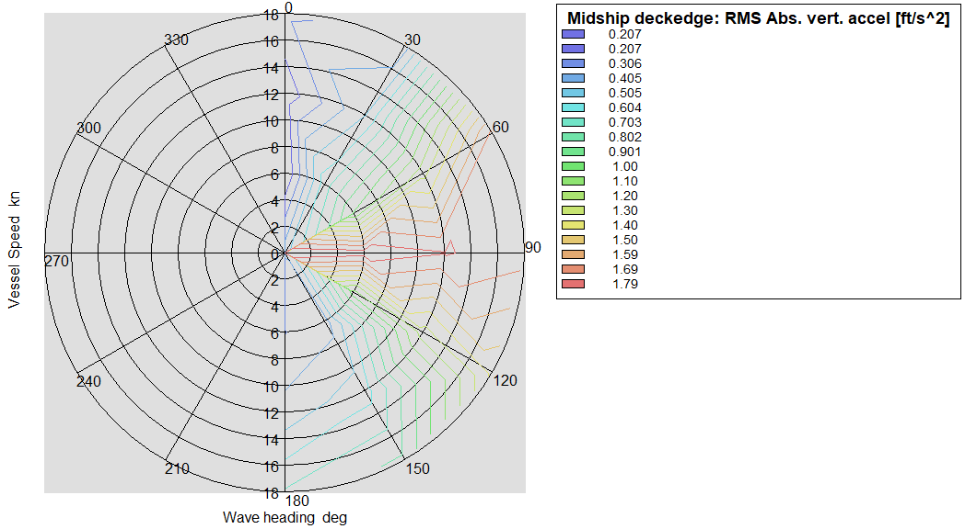
Figure 37. Heave Acceleration (ft/s²) in Sea State Four

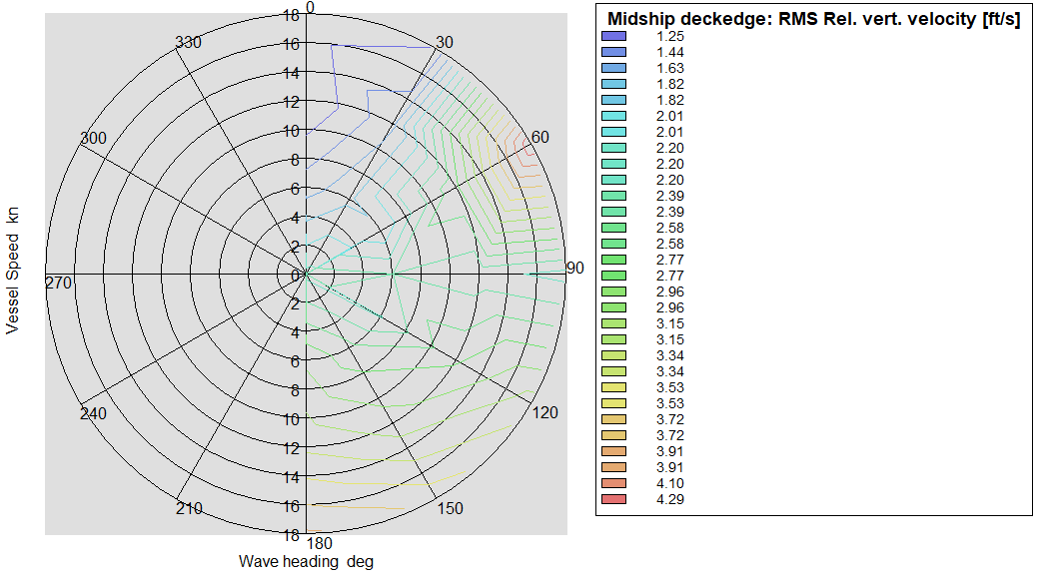
Figure 38. Heave Acceleration (ft/s²) in Sea State Five
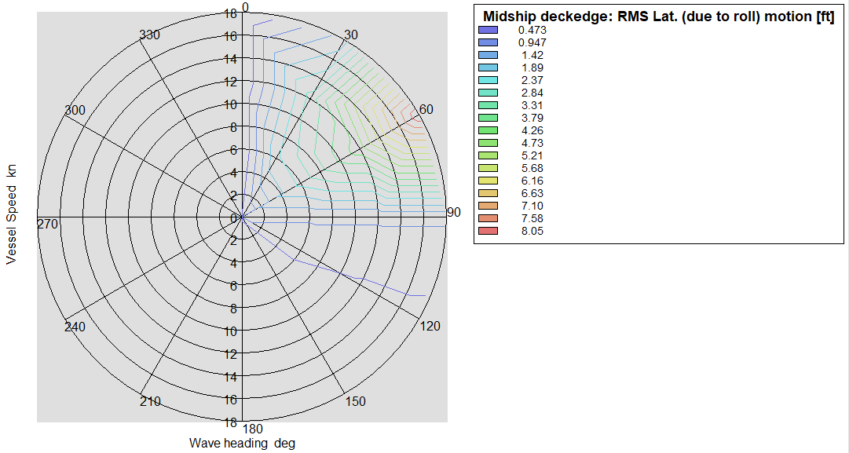
Figure 39. Roll Motion Amplitude (deg) in Sea State Four
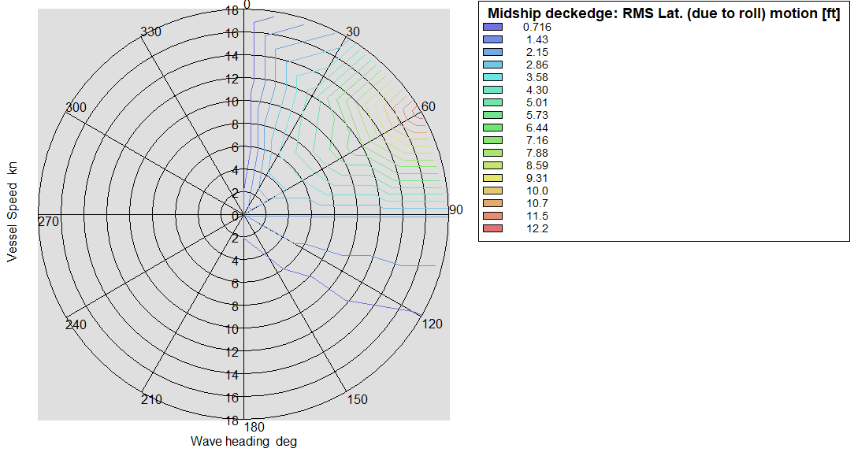
Figure 40. Roll Motion Amplitude (deg) in Sea State Five

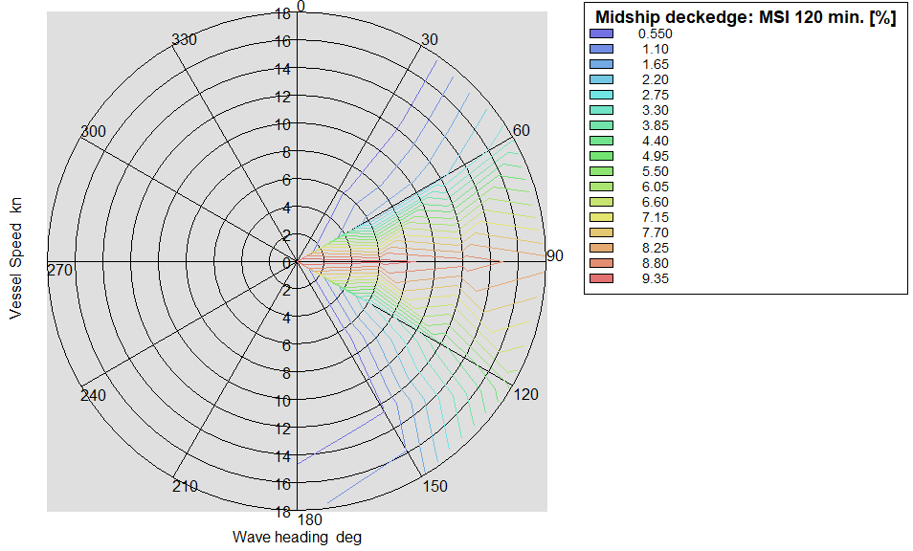
Figure 41. Motion Sickness Indicator After 120 Minutes (%) in Sea State Four
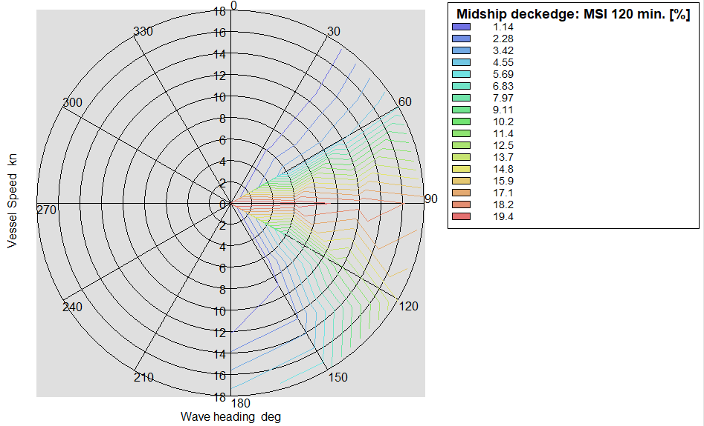
Figure 42. Motion Sickness Indicator After 120 Minutes (%) in Sea State Five

Manning Estimate
The AR-24 manning analysis demonstrates a need for 933 personnel. Unlike current tenders, the AR-24 will embark an all active duty U.S. Navy crew. The vessel’s expected organizational structure requires 11 Senior Officers and 800 junior enlisted sailors (E-1 to E-6) in addition to 36 Chief Petty Officers (CPO), Limited Duty Officers (LDO), and Chief Warrant Officers (CWO). A 10% margin for future crew expansion would grow the crew to 13 senior officers, 40 CPO/LDO/CWOs, and 880 junior enlisted personnel.

Rank | Design Crew | (10%) Margin
Senior Officer  (O-5 +) | 11 | 13
JO/CPO/LDO/CWO | 36 | 40
Enlisted  (E-1 to E-6) | 800 | 880
Surge Berthing | 360 | 396
Table 25. Manning Analysis
Figure 43 shows the expected organizational structure of the AR-24. The Repair Department has a throughout breakout as it is the mission critical department for the vessel. Additionally, the vast majority of personnel assigned to the vessel will serve in the repair department. Estimates for department manning are derived from an analysis of the all-active duty crewing model used on the submarine tenders before they introduced a mixed crewing model with Military Sealift Command.

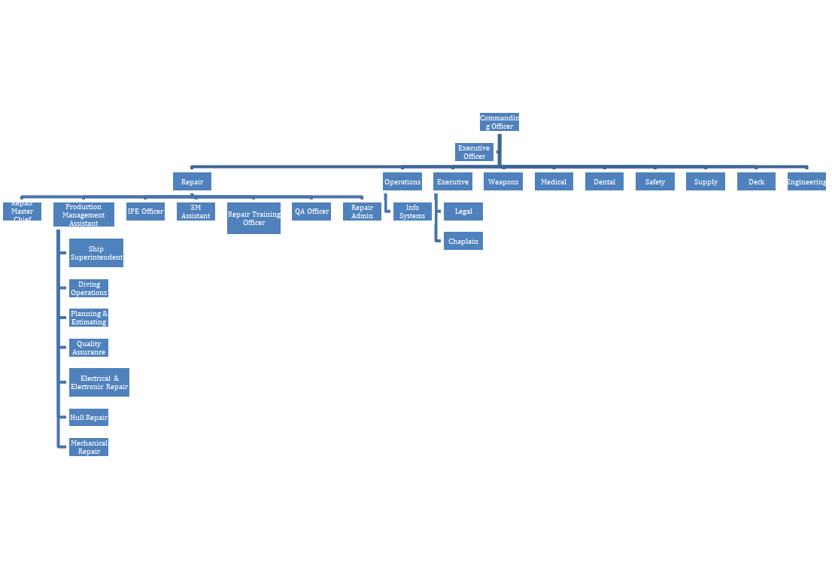
Figure 43. AR-24 Organizational Chart with Repair Department Break Out

Cost Analysis
A variety of cost estimates strategies were used to determine approximate, initial costs of the AR-24. The first strategy used to complete this was to use the Project-Oriented Design and Construction Cost Model. The PODAC Modeling Spreadsheet was used with the conditions outlined in Table 5 to yield the Present Lead Ship Cost for the AR-24, adjusted for inflation at the grand total of $698,000,000 (Ennis, 1997).
Variable | Response
Ship Type | Repair Tender
Type Factor | 4.5
Ships in Series | 6
Year | 2030
Size Factor | 0.96
Inflation Rate | 2.5%

Table 25. PODAC Variables
The second method was using a US Navy-sponsored research paper, entitled, “Cost Estimating Relationships for US Navy Ships” on cost estimation for a variety of ships to include underway replenishment ships and repair tenders. This method included using the chart in Figure 45 and comparing full load displacements to cost. When adjusted for inflation for the year 2030, it was estimated that the AR-24 would cost $414,920,627.21 (Shafer, 1983).
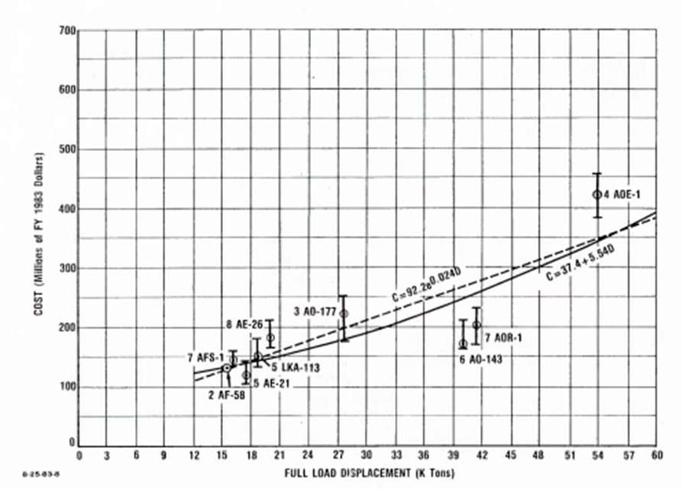
Figure 44. Cost Analysis Plot
Table 34 shows the cost estimation comparisons side-by-side. The discrepancy between these two costs is nearly $200,000,000.00, this can be accounted for by the US Navy Research and PODAC paper not fully covering a range of smaller repair tenders. Further analysis may help point to a median value which places the cost of the AR-24 and following ships in the class at approximately half a billion dollars a unit.
PODAC Method | $698,000,000
Navy Research Paper | $415,000,000

Table 26. Cost Estimation Comparison
These estimates are lower than the current approved Navy solicitation for a new class of submarine tenders, valued at $1.7 billion. While the specific details of such an estimate are unavailable, this number is much larger than the AR-24 Valkyrie estimate due to the larger size of classic submarine tenders, the cost associated with designing a new class of ship, and the cost of ensuring a submarine tender is able to provide SUBSAFE work packages (Wilson, 2023).

It is believed that the PODAC estimate is most realistic.

Risk Assessment

Strengths | Weaknesses | Opportunities | Threats
The AR-24 does a good job remaining on station and providing the space and resources to fulfill the mission in a smaller platform. | Competitors have created tenders which are larger than our design. There are currently 2 submarine tenders and no other repair tenders currently being built. | With shipyards being the biggest competitor of the, there is much opportunity for development in this field. | US resistance to expand their support and repair tender ship building and manning poses the primary threat to the creation of the AR-24.
Features which make the AR-24 stand out include VLS Storage, updated navigation systems and repair systems. | The AR-24 lacks true innovation in design, it is simply a large displacement vessel with space for crew and work to be accomplished. | The AR-24 fills an underserved gap in the US Navy. Trending features to positively impact this design include the geopolitical climate. | Congressional budgetary pressures $1.2 Billion for AS(X) struck from FY24 NDAA.
Resources that strengthen this design are technical resources from both public and private shipyards and NAVSEA. | Due to the long ranges of the ship and the amount of time a ship is expected to remain on station limited by fuel, water, and provisions. | With the rising conflicts, especially in the South China Sea with near peer competitors there is an emerging need for such a platform.
Table 27. Risk Assessment

Appendix

Appendix A. Lines Drawing
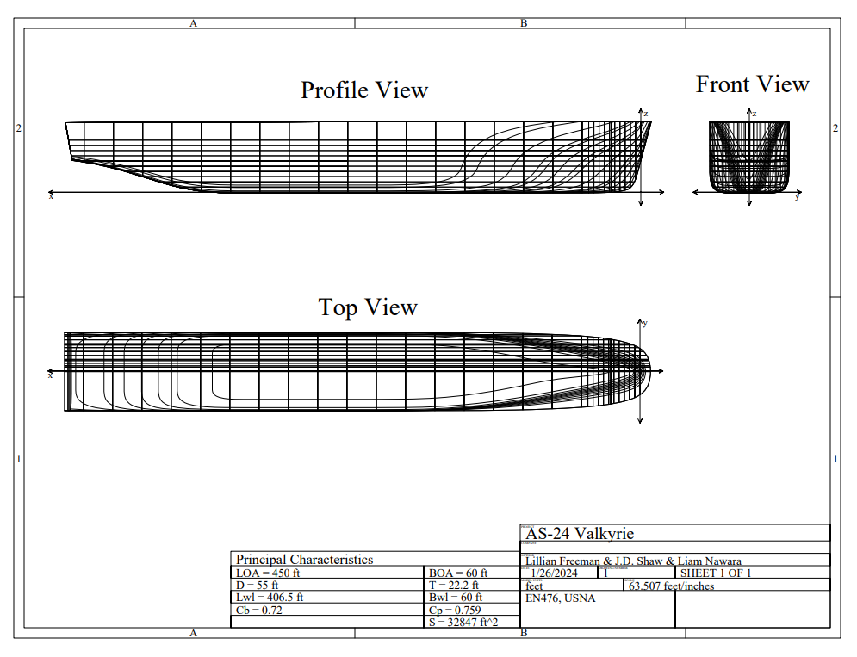

Appendix B. General Arrangements

02 Level
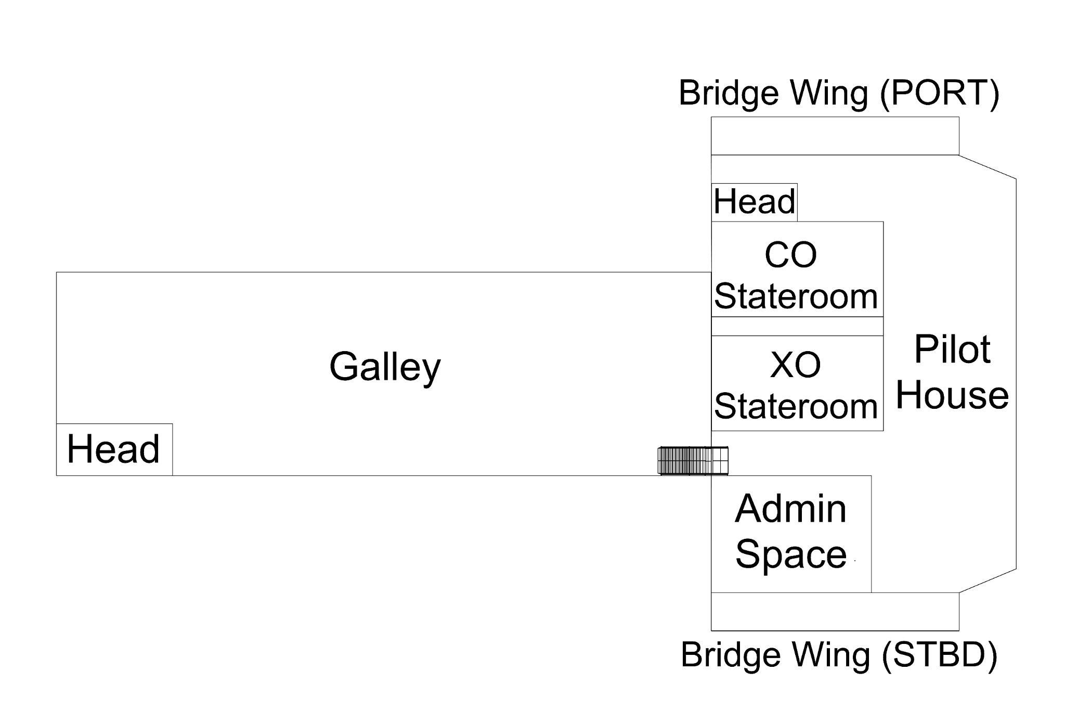

01 Level
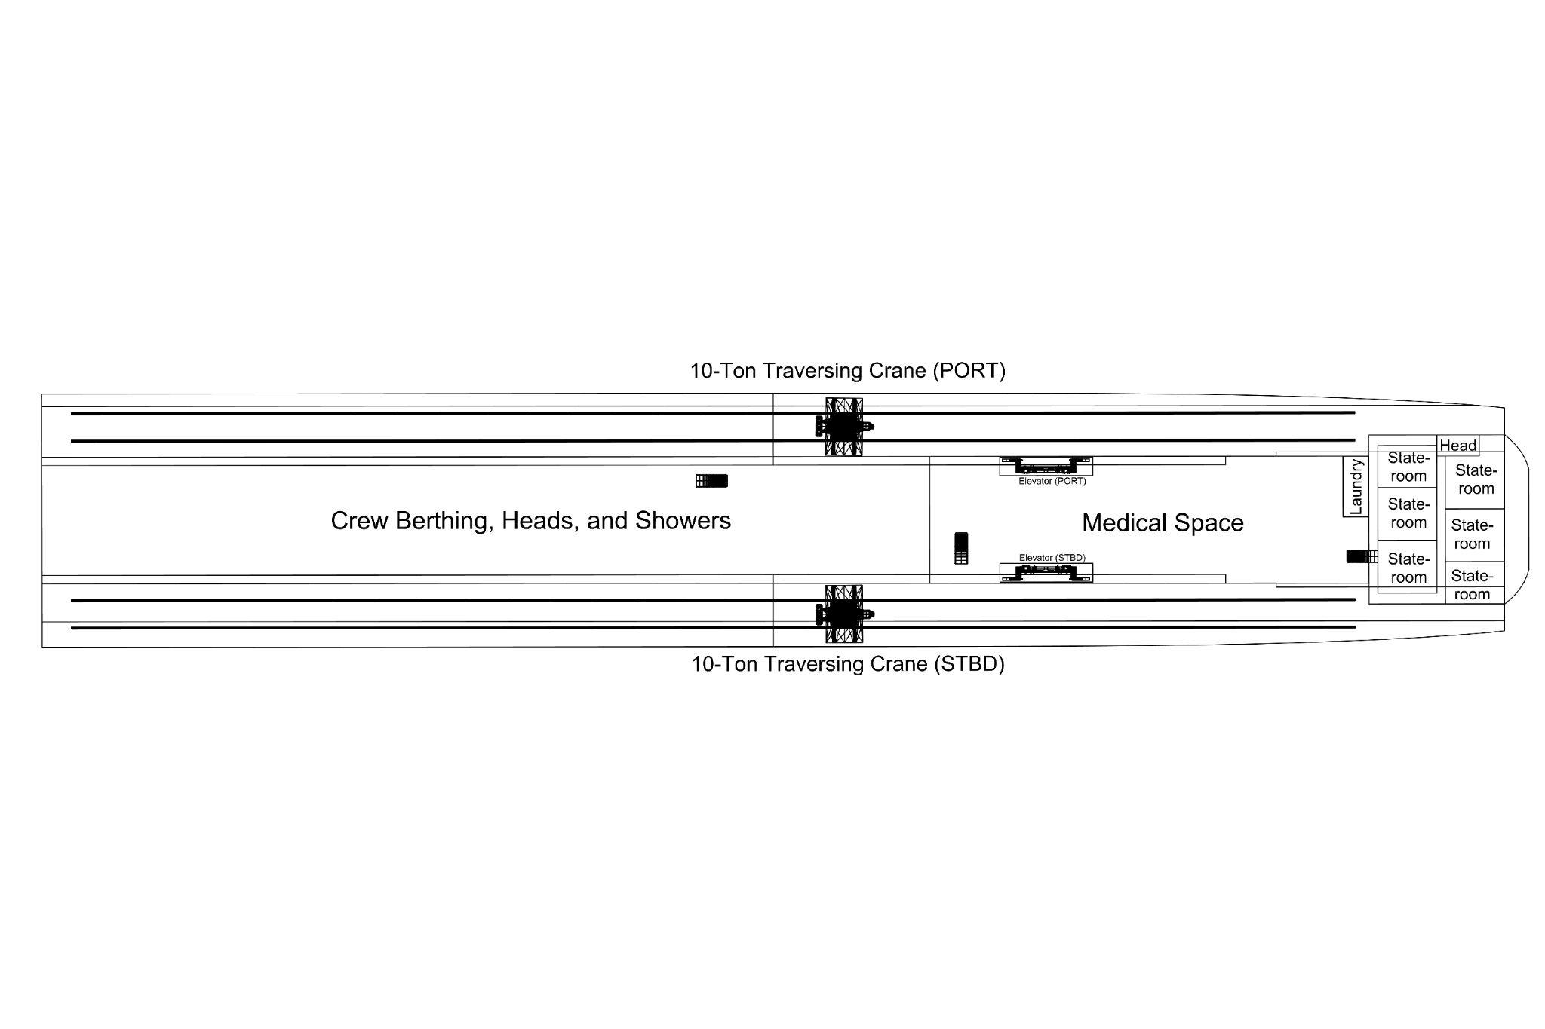

Main Deck
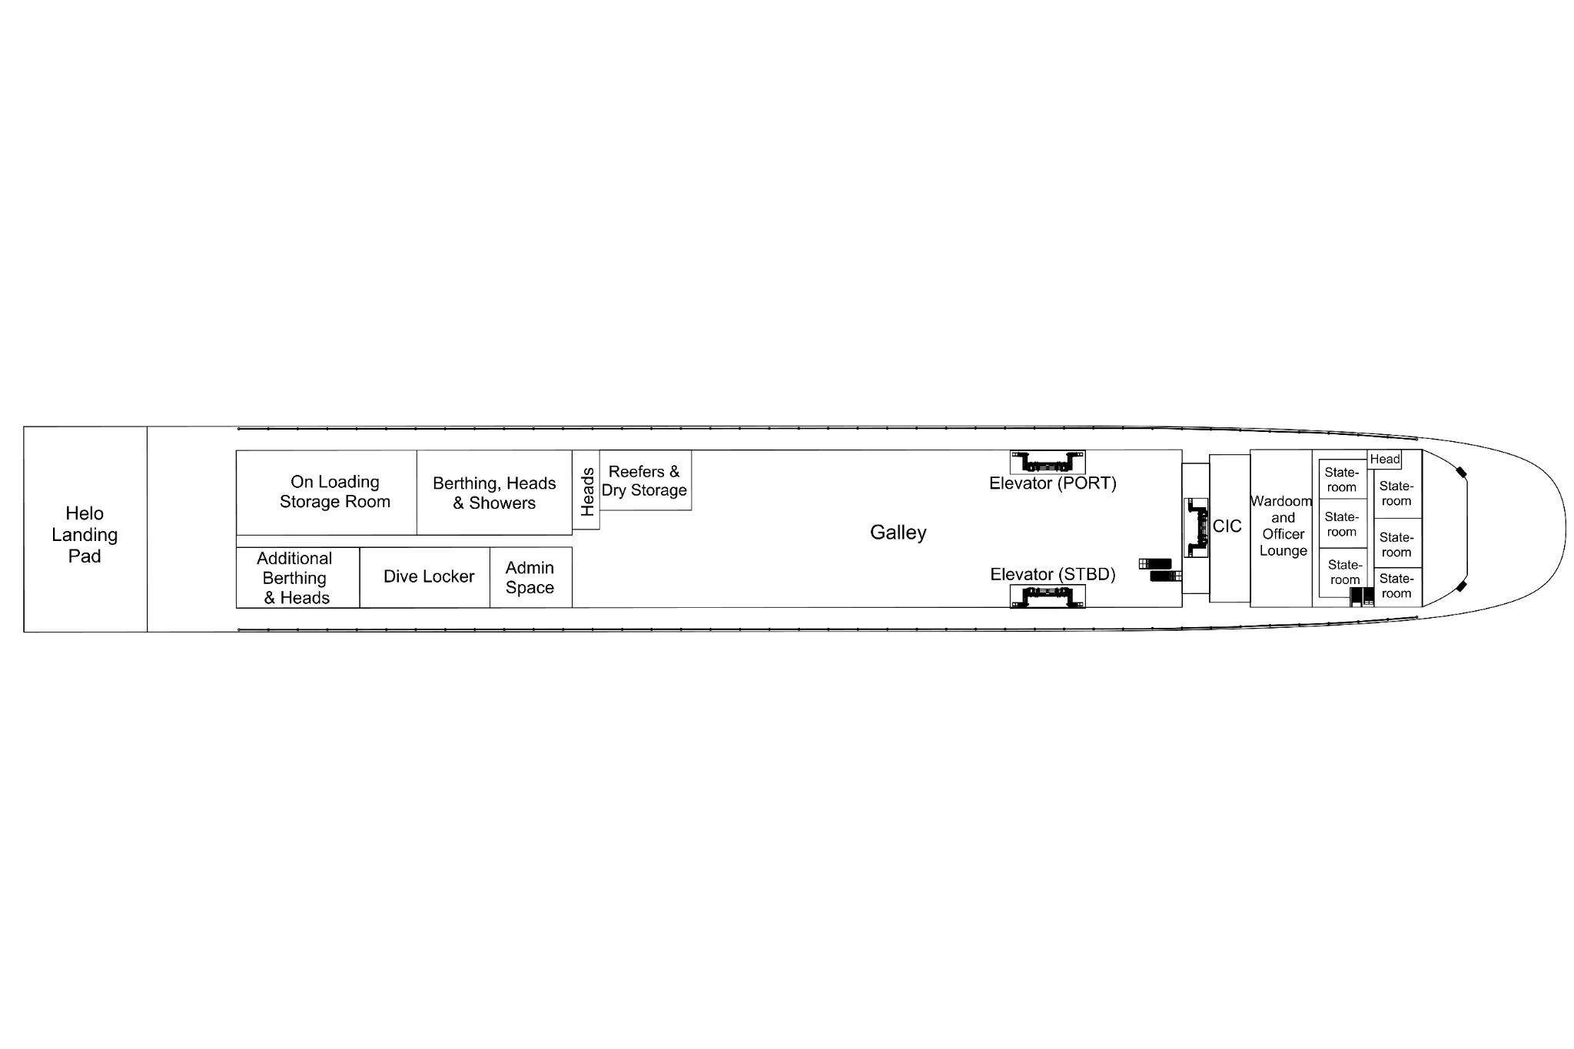

1st Deck
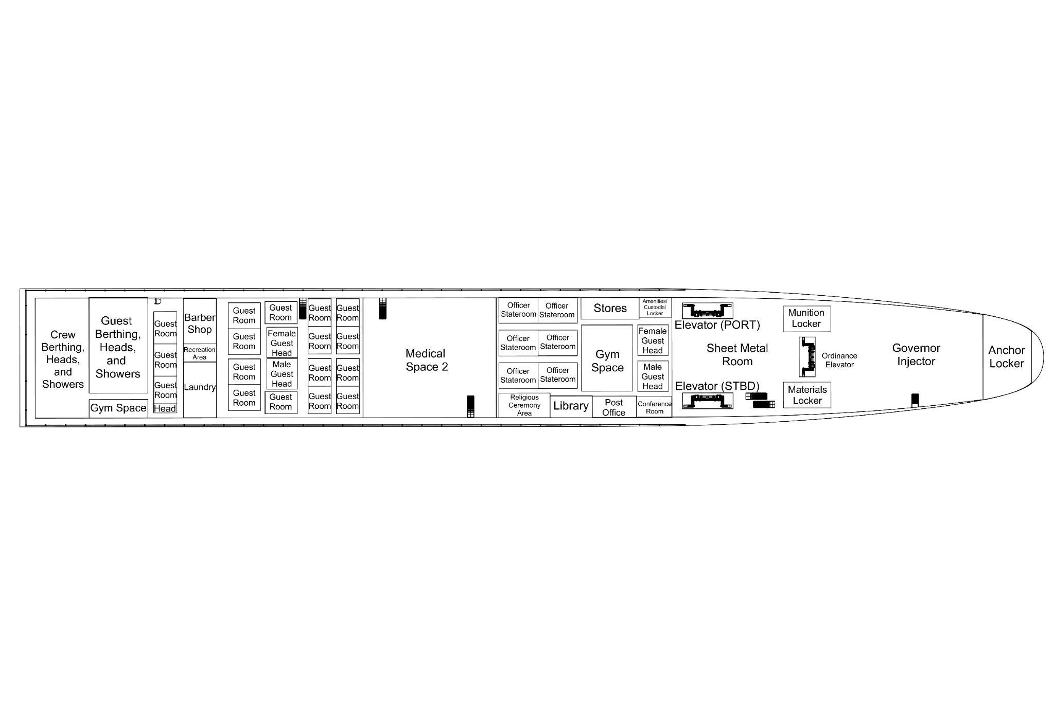

2nd Deck
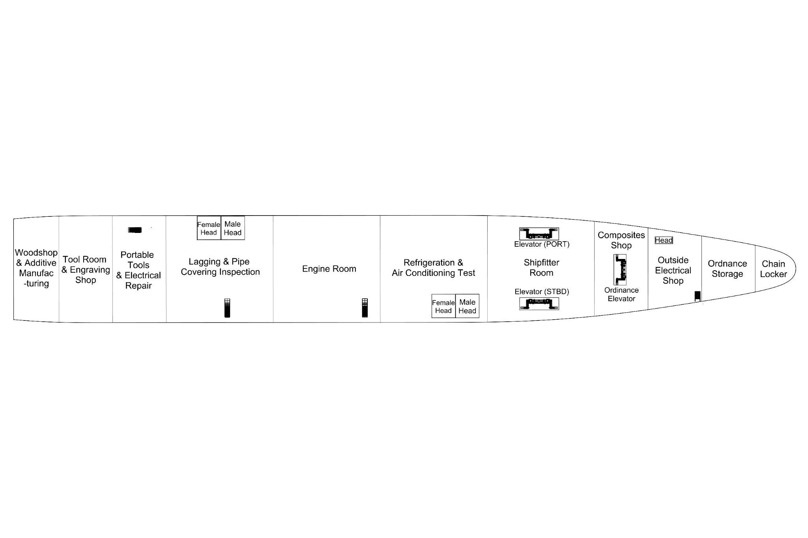

3rd Deck
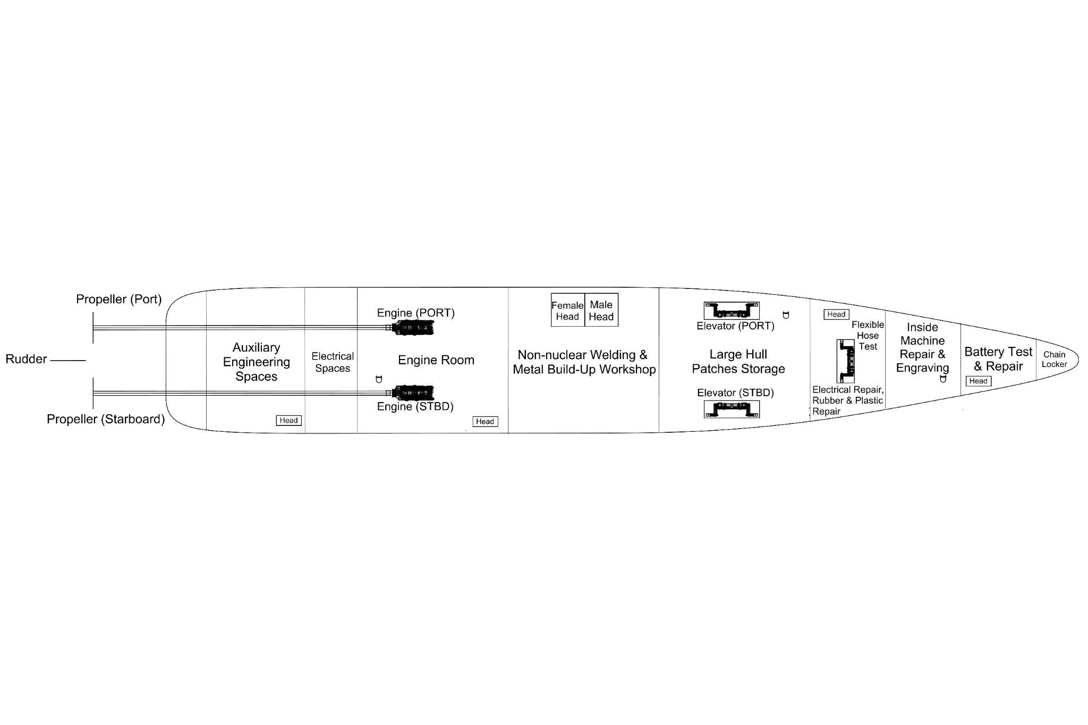

Appendix B. Capacity Plan

Cargo Holds Tanks (Bilge Deck)
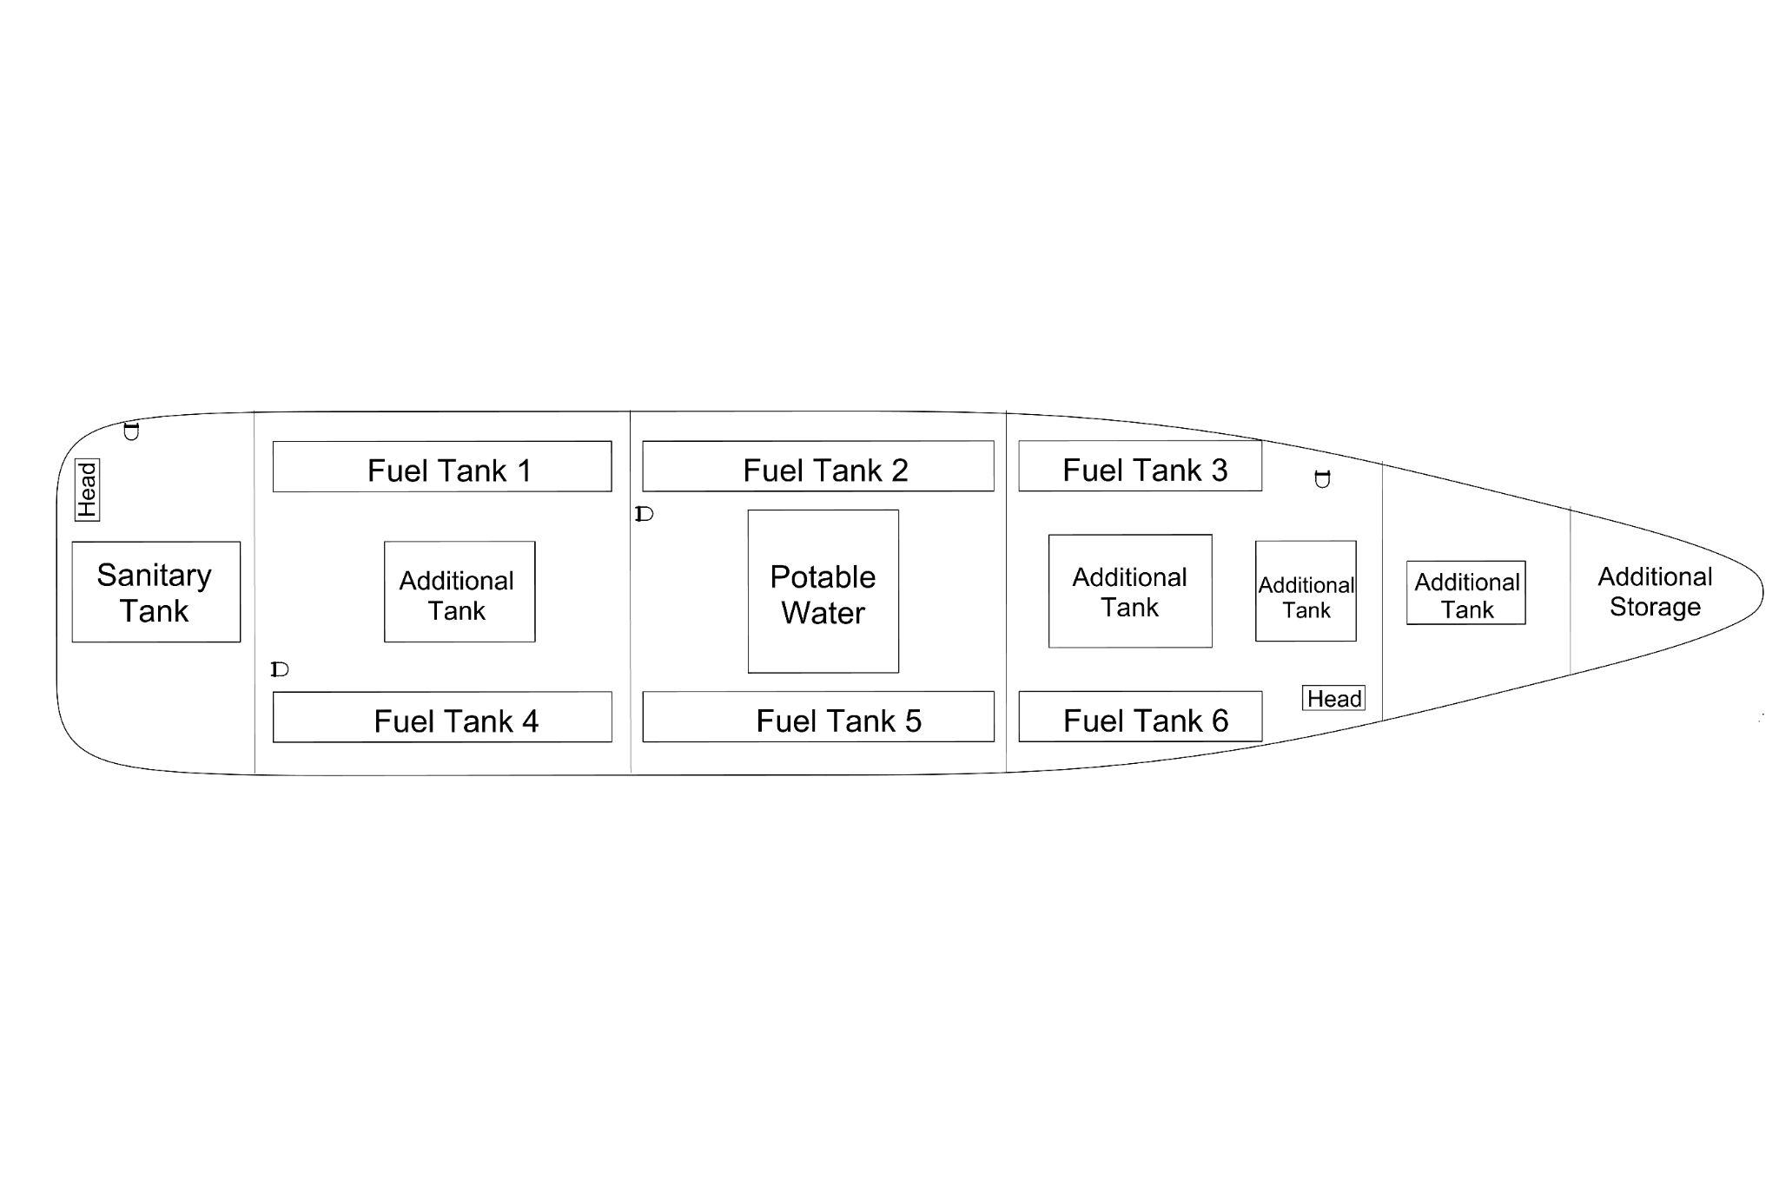

Midship Section Drawing
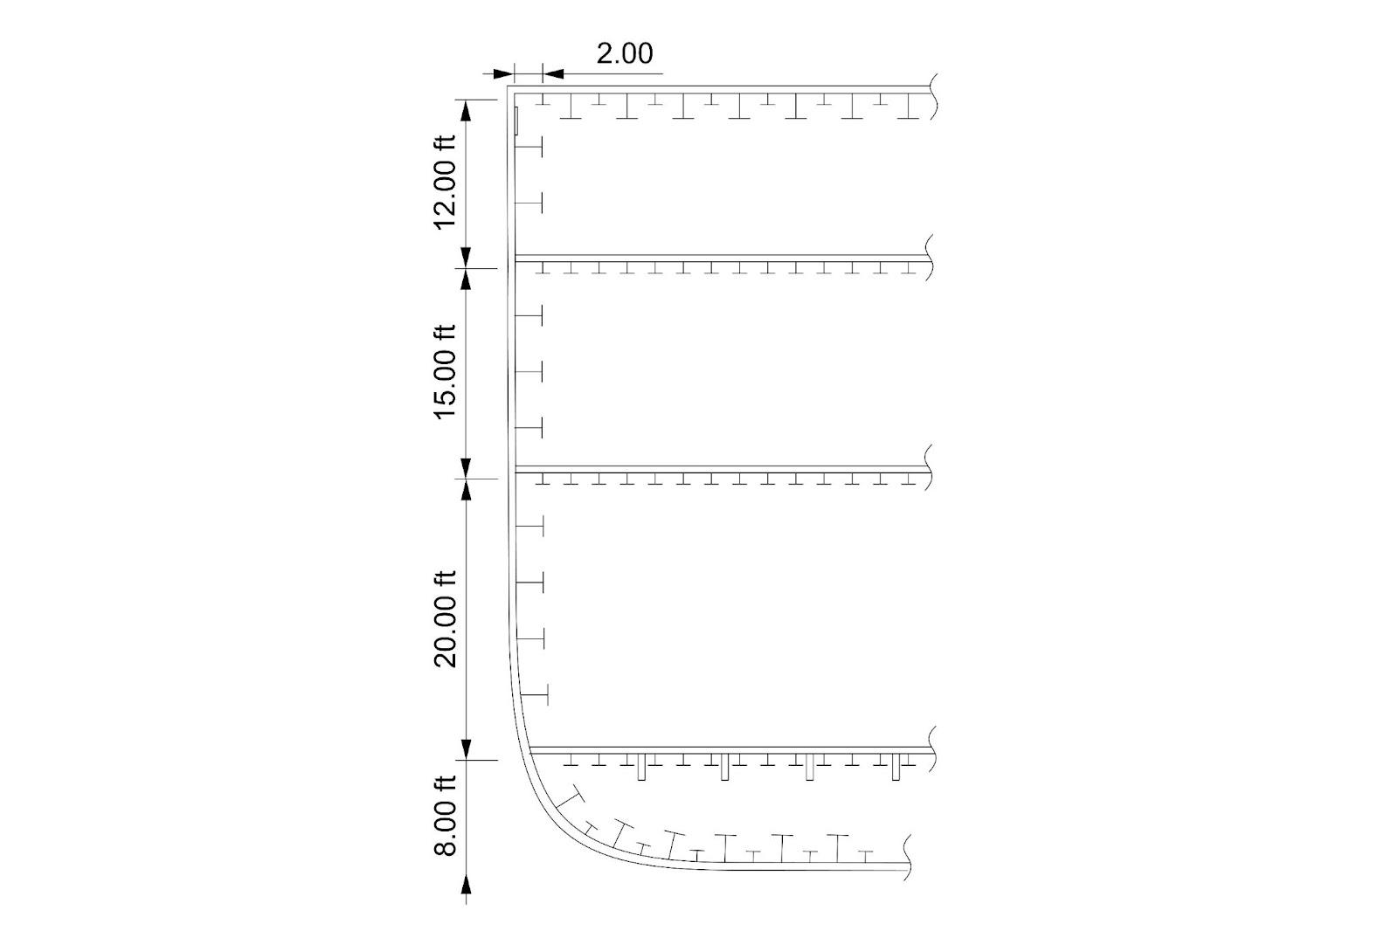

Appendix C. Machinery Arrangement

Table of Principal Components

Space | SWBS | Area (FT^2) | Weight | Weight w/ 15% service margin | lcg | tcg | vcg | Comments
- | - | - | LT | Long Ton (LT) | ft | ft | ft | Referenced from FP, CL, BL
Hull and Superstructure | 100 | - | 3714 | 4271 | 275 | 0 | 20 | SWBS Group Estimates of AS-41 Parent Hull to AR-24
Drive Train Port | 200 | 3240 | 420 | 483 | 360 | 15 | 18 | SWBS Group Estimates of AS-41 Parent Hull to AR-24 and AS-41 Weight Report
Drive Train Stbd | 200 | 3240 | 420 | 483 | 360 | -15 | 18 | SWBS Group Estimates of AS-41 Parent Hull to AR-24 and AS-41 Weight Report
Centerline Stack | 200 | 100 | 19 | 22 | 249 | 0 | 85 | AS-41 Weight Report
Electric Power Generation | 300 | 1120 | 340 | 391 | 400 | 0 | 20 | AS-41 Weight Report
Bridge | 400 | 448 | 31 | 35 | 50 | 0 | 72 | Scaled from SWBS Group Estimates of AS-41 Parent Hull to AR-24
Navigation Equipment | 400 | 300 | 6 | 6 | 60 | 0 | 90 | AS-41 Weight Report
40 Ton Crane | 500 | 200 | 200 | 230 | 252 | 0 | 70 | Estimate from comparable marine crane weights
Port Crane | 500 | 200 | 40 | 46 | 196 | 26 | 60 | Estimate from comparable marine crane weights
Starboard Crane | 500 | 200 | 40 | 46 | 196 | -26 | 60 | Estimate from comparable marine crane weights
Berthings | 600 | 20320 | 183 | 211 | 400 | -16 | 49 | SWBS Group Estimates of AS-41 Parent Hull to AR-24
Medical Spaces | 600 | 14185 | 53 | 61 | 248 | 0 | 70 | Scaled SWBS Group Estimates of AS-41 Parent Hull to AR-24 and AS-41 Weight Report
Anchor Locker (Forward) | 600 | 624 | 200 | 230 | 20 | 0 | 42 | USS EMORY S. LAND (AS 39) 2013-2014 Operations Brief
Windlass/Capstan | 600 | 100 | 34 | 39 | 20 | 0 | 42 | SWBS Group Estimates of AS-41 Parent Hull to AR-24 and AS-41 Weight Report
Dive Boat | 600 | 400 | 38 | 44 | 275 | 0 | 80 | Disscusion with prior USS FRANK CABLE Repair Officers on Capstone trip to NNSY
Capital Equipment WS#1 | 600 | 4160 | 108 | 125 | 370 | 0 | 35 | Estimate from AS-41 Weight Report on repair equipment outfitting.
Capital Equipment WS#2 | 600 | 24932 | 551 | 633 | 70 | 0 | 30 | Estimate from AS-41 Weight Report on repair equipment outfitting.
Capital Equipment WS#3 | 600 | 24000 | 425 | 489 | 100 | 0 | 14 | Estimate from AS-41 Weight Report on repair equipment outfitting.
Cargo Munitions Handling and Stowage | 700 | 1920 | 240 | 276 | 30 | 12 | 35 | Estimated calculation assuming 100 weapons stows in MK13 Canisters (mix of Standard Missile, TLAM, etc); AS-41 weight Report
MK15 CIWS Fore | 700 | 40 | 6 | 7 | 400 | 0 | 60 | From USN System Placemat
MK15 CIWS Aft | 700 | 40 | 6 | 7 | 50 | 0 | 60 | From USN System Placemat

References
ABS. "Rules for Building and Classing Marine Vessels Part 4 Hull Construction and Equipment." Spring, Texas: American Bureau of Shipping, 2024.
CISIS Missile Defense Project. "China's Regional Missile Threats." CSIS, n.d.
Eckstein, Megan. "US Navy works to speed up damage assessments, ship repairs." Defense News 13 January 2022.
Ennis, D. L. G. Z., 1997. Product-Oriented Design and Construction Cost, Jersey City: SNAME Ship Production Symposium.
GAO. "Navy Ships: Timely Actions Needed to Improve Planning and Develop Capabilities for Battle Damage Repair." 2021.
Gonzalez, Thomas Shugart and Javier. "First Strike: China's Missile Threat to U.S. Bases in Asia." 2017.
Morabito and Jaye Falls. 2019.
MTU Rolls-Royce. "Marine Diesel Engines 16V 8000 M71L for fast vessels with high load factors (1B)." n.d.
NAVSEA. "DDS-079-1 DESIGN PRACTICES AND CRITERIA FOR U.S. NAVY SURFACE SHIP STABILITY AND RESERVE BUOYANCY." PUBLISHED BY DIRECTION OF COMMANDER, NAVAL SEA SYSTEMS COMMAND, 2016.
Prouty, Trevor. "Forward Battle Damage Repair Keeps Ships in the Fight." USNI Proceedings January 2022.
Shafer, W. J. "Cost Estimating Relationships for US Navy Ships." Alexandria: Institute for Defense Analyses, 1983.
Strategy, National Security. National Security Strategy. Washington: The White House, 2022.
Wikipedia. Phalanx CIWS. 18 May 2024. April 2024.
Wilson, N., 2023. Inside Defense: Navy releases solicitation for next-generation submarine tender. [Online]

